Autonomous Robot “PHOENIX-1”

Alexey Dmitriev, Alexey Mikheev

Saint-Petersburg State University of Aerospace Instrumentation,
Saint-Petersburg, Russia

Abstract

This work concerns experimental research of “Teaching by Showing” approach for multi channel real time control systems based on neural network. The supervised teaching paradigm can be interpreted as nonlinear curve fitting problem. For such systems, one step teaching procedure was proposed. This procedure uses Tikhonov regularization. The approach was experimentally investigated during the first phase of
student research project “Autonomous Robot PHOENIX-1”.
Robot “PHOENIX-1” was designed to orientate in environment with web-cam. As the first step, robot has to be learned to follow white stripe using video stream from web-cam. Experiments with 5 sensors / 1 actor control system confirmed the reliability and effectiveness of proposed approach.

I. INTRODUCTION

Control systems based on neural networks are in field of interest of modern control theory [1].
One step learning procedure was proposed for control system on base of neural net [2]. It was shown that supervised learning paradigm can be interpreted as a nonlinear curve fitting problem. It was proposed to use the least square approach and Tikhonov regularization method of cost function to get a correct solution for weight set for neural control net. In this case a result can be expressed analytically as

w = (S^{T} S + γ E) ^{–1} S^{T} a (1.1)

where w – the neural net weight set, S – is a rectangular matrix of inputs, formed from sensor measurements, a – a vector of actor signals, formed by operator during showing phase and γ is regularization coefficient. More details are presented in work [2].
This idea was experimentally investigated during student research project “Autonomous Robot PHOENIX-1” [4]. Project “Phoenix-1” was started 02/04/05 and was realized by mixed student and engineer team during autumn semester. Backbone of team is formed from students (4221 and 4022 student groups) and engineers of Student Design Center of SUAI.
To check possibilities of one step learning procedure, ze control system with one actor and five optical sensors was used. In this case teaching model is rather simple and can be described with

S₁(T₁)…S_{Ns}(T₁)…S₅(T₁)…  S₁(T₂)…S₂(T₂)…S₅(T₂)…  ………………………….  S₁(T_{p})…S₂(T_{p})…S_{n}(T_{p})… | * | W₁  W₂  W₅ | = | A₁(T₁)  A₁(T₂)  (1.2)  A₁(T_{p})

w = (S^{T}S+γ E) ⁻¹ S^{T} (1.3)

These experiments confirmed the reliability and effectiveness of proposed approach. Also, engineering database was created and used for autonomous robot PHOENIX-2 design. This work is a brief review of the results achieved during the first phase of the project.

II. ROBOT PHOENIX-1 DESIGN

Autonomous robot PHOENIX-1 is a test platform for research in fields related with neural network control system. Flexibility was one of the main characteristics of robot design, due to parallel work on theory, components and experiments.
The “teaching by showing” methodology was experimentally investigated during the first stage of the project. In this phase robot has to be learned to follow white stripe using current image from web-cam.
Robot’s design and control system structure are presented on the Fig.2.1. Robot PHOENIX-1 has two motor driven wheels and a passive one. Web-cam image was processed with the software, running on a notebook. The results of processing were used as sensor inputs for a neural net, realized by the high level software. This software generates and sends command to low level controller through RS-232 interface.

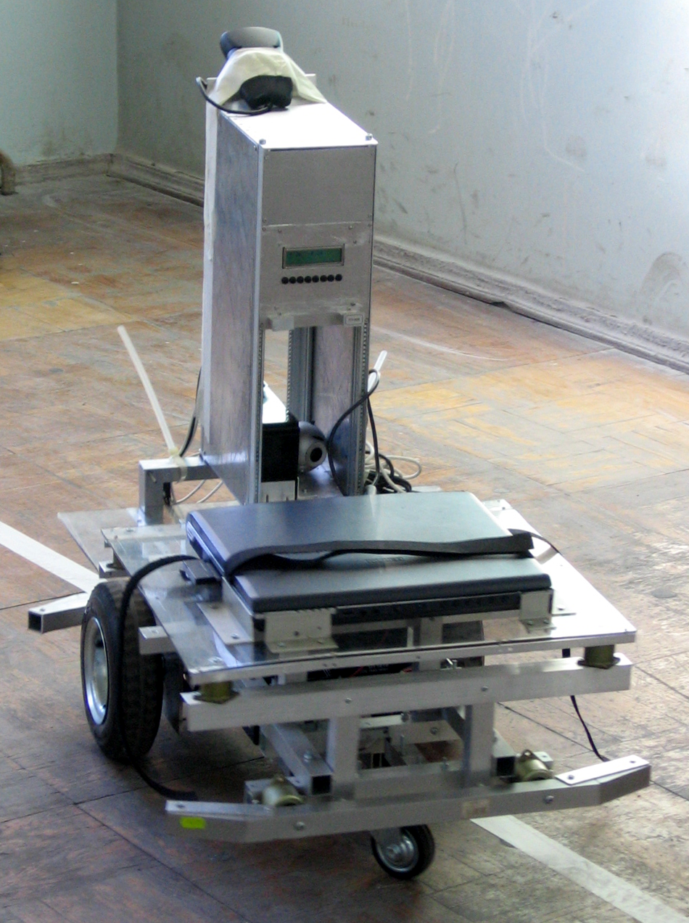
Left and Right
Motor Control
Bridges
Actors
Web -camera
Laptop
Toshiba
High level

Controller
ASK-Lab
Rotation
Speed
Sensor -2
Rotation
Speed
Sensor -1
Low
level
RS-232
Sensors
Fig. 2.1 “PHOENIX-1” control system structure

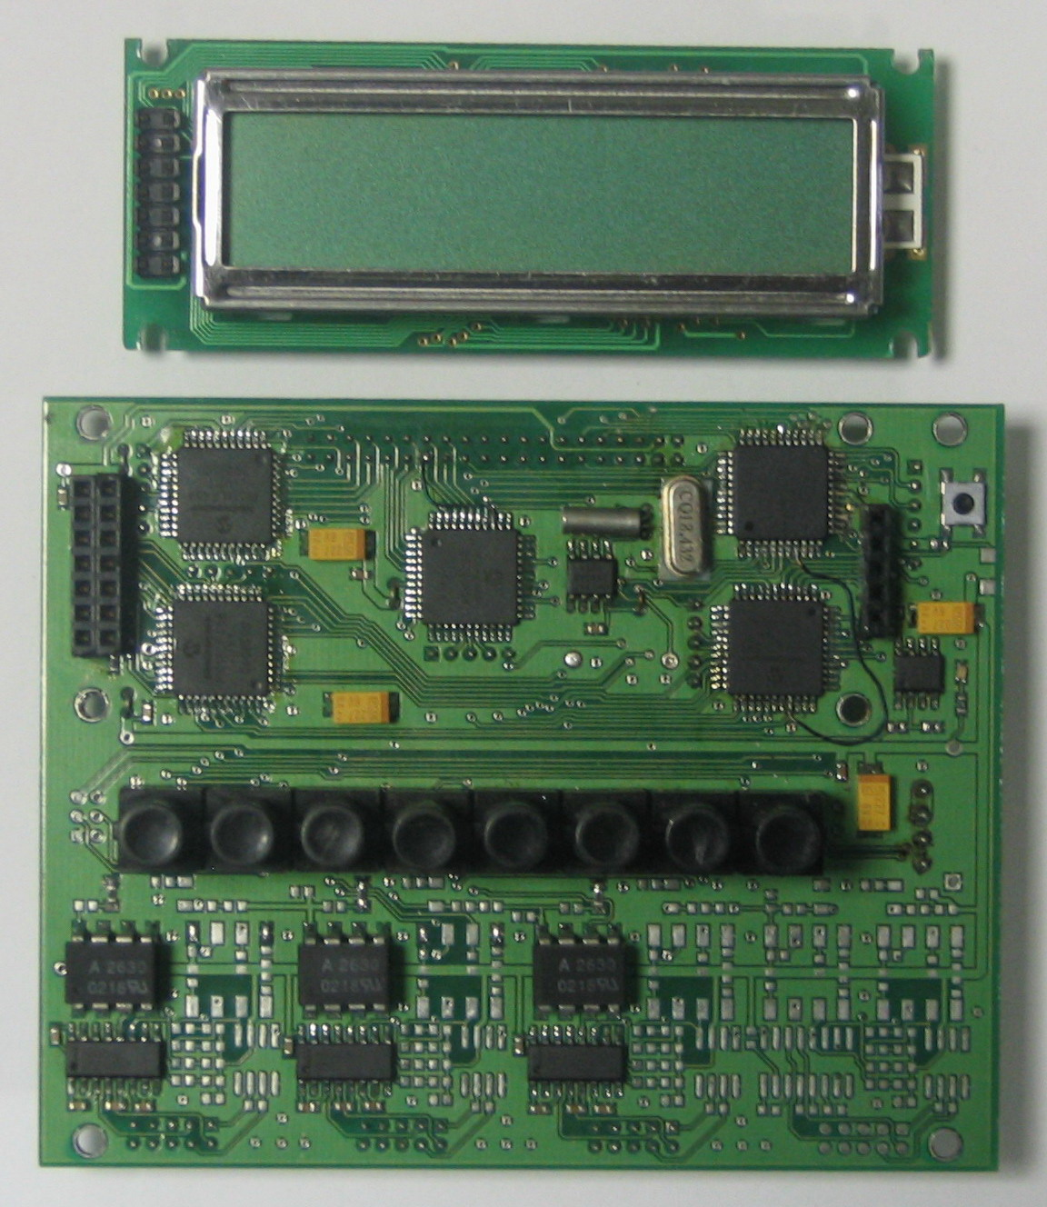
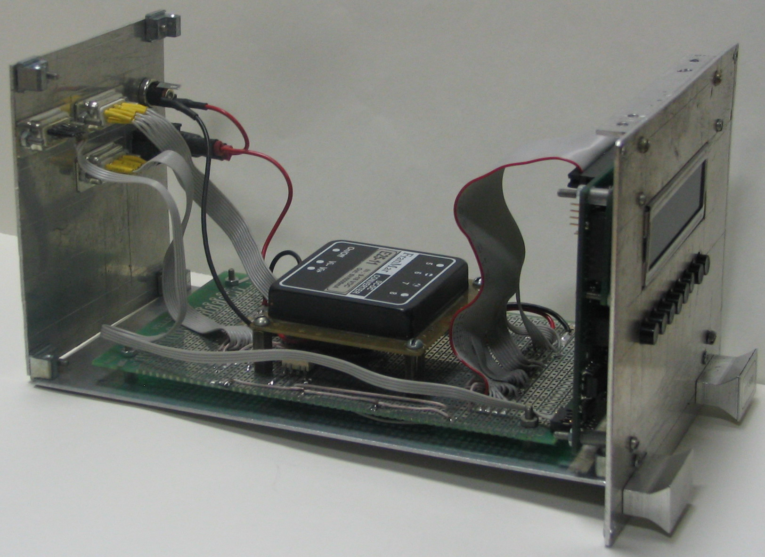
LCD
P18
МS
P18
SL
P18
SL
P18
SL
OPTO
DECOUP
OPTO
DECOUP
OPTO
DECOUP
OPTO
DECOUP
ALTERA
RTC
I2C
Keyb
D
I/O
D
I/O
A/D
I/O
D
I/O
CANbus 2.0
USART
RS232
RS422
RS485
CANbus 2.0
USART
RS232
RS422
RS485
CANbus 2.0
USART
RS232
RS422
RS485
CANbus 2.0
USART
RS232
RS422
RS485
CLK
RST
supervisor
RST
Q, 32.768
Q, 20MHz
BAT
3V
LED
PIC
Buttons
Optron
Interface
Chip
Interface and
Power Module
Controller
Figure 2.2 PHOENIX-2 low level controller

Structure and view of the robot’s low level controller is presented on the Fig.2.2. The industrial ASK Lab controller platform was used [5]. This platform was developed by the staff engineers of Student Design Center (SUAI). Original IDE “Constructor A3” was used to develop low level software for controller.
The controller has multiprocessor architecture that was implemented with four PIC18F458 connected with I2C bus. Controller has four external optoelectronic couples for industrial interfaces like RS232, RS422, RS485 and CanBus. It is clear that only few of possibilities of ASK Lab controller were used for current project, but this solution reveals possibility to use a different sensors in future version of robot.
According to [2], there are several steps in neural system synthesis using “teaching by showing” method. On the 1st step robot’s movement are controlled by a traditional control system or by operator. During this procedure robot’s sensors information and control commands are written. This data is used on the 2nd step for neural regulator coefficients count.
In our experiments we have tried 2 control schemes – one with analog and one with digital control channel. The scheme that uses analog radio channel is presented on the Fig. 2.3. As it can be seen from the figure, operator has a control console with radio transmitter. Operator’s control commands are transmitted and received by special radio receiver, located on board of the robot. These control commands are decoded by controller and then converted to executive signals for the actors. Simultaneously, video from web-cam and information from speed sensors is passed to the laptop, where it is written to a hard disk for further analysis.
Digital control scheme is presented on fig.2.4. In this scheme we used standard equipment for building wireless (Wi-Fi) networks – access point and Wi-Fi adapter, both based on Orinoco Silver card. So, in this scheme we have digital channel between operator and the robot, and this gives us serious advantages. Now operator has live video from robot’s web-cam, operator’s commands are transmitted by computer network with all advantages of TCP/IP stack (such as reliability, duplicate detection, sequencing, etc). And of course we have all, we had in previous case – video and speed sensors information is saved on the laptop. And now we use exactly this scheme of control in our experiments.

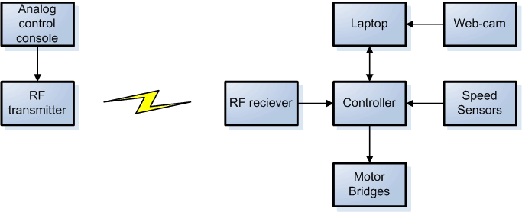

Fig. 2.3 Analog Control Channel

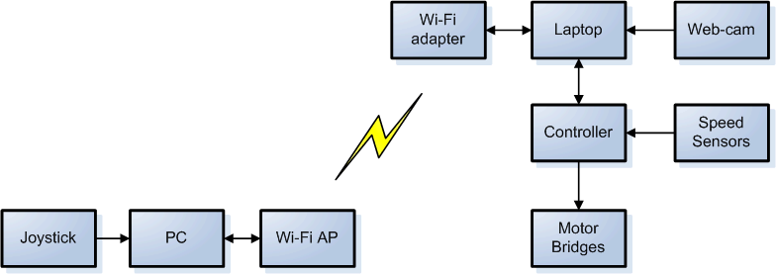

Fig. 2.4 Digital Control Channel

During experiments with digital channel equipment complied with 802.11b standard 802.11b was used. In accordance with specification, maximum raw data rate is 11 Mbit/s, but in our experiments typical data rate was about 2Mbit/s. In fact even this rate was sufficient, due to video compression (Cinepak codec) that we used for video stream.
During showing with human being as “OPERATOR” it was supposed that a standard joystick can be used. For robot control two independent channels, “acceleration” and “turning”, were used. Acceleration channel defines the value of PWM signal and turning channel defines difference between left and right motor that provides robot’s turn. Joystick’s coordinate system is presented in Fig.2.5.

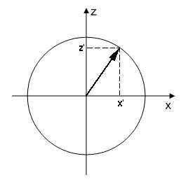
Fig. 2.5 Joystick’s coordinate system

Joystick’s coordinates are in -255…255 range. Depending of combination of “X axis sign, Z axis sign” we use a little bit different formulas, but they all have the same idea. On fig.2.5 Z axis represents acceleration channel and X axis represents turning channel. So, when we have situation, shown on this figure our formulas will take this form:

$\left\{\begin{matrix}\text{PWM}1=\left|Z'\right| \\ \text{PWM}2=\left|Z'−\frac{X'}{S}\right|\end{matrix}\right.$, for $\frac{X}{S}≤Z$ (2.1)
$\left\{\begin{matrix}\text{PWM}1=\left|Z'\right| \\ \text{PWM}2=0\end{matrix}\right.$, for $\frac{X}{S}>Z$ (2.2),

where PWM1, PWM2 – values of PWM signal for left and right motors,’Z’ – Joystick’s “z” coordinate, X’ – Joystick’s “x” coordinate, S – sensitiveness – adjustable coefficient that represents drive “sharpness”.
During first phase experiments with robot PHOENIX-1 control system with 5 optical sensors and one actor channel was investigated. The difference between PWM for left and right motors

A ₁ (T) = left_motor_PWM (T) –
right_motor PWM (T) (2.3)

was used as actor signal.

III. STRIPE RECOGNITION

Robot “PHOENIX-1” was designed to orientate in environment with web-cam. That means that development of an optical sensor is a one of the key points of the project.
As the first step, robot has to be learned to follow white stripe using video stream from web-cam. The primary objective of a sensor is to measure displacement of a contrast stripe from the image center. Performance of recognition and control algorithm is the main criteria of the optical sensor design, because of intensive video stream that robot cam produces (its rate is about 25-30 fps).
The principal idea of stripe recognition algorithm is based on the assumption that stripe has homogeneous color and high contrast with background. Sample video frame illustrating the main idea is schematically shown on the figure 3.1. The gray area on the picture is background. The black stripe is a measuring stripe. All calculations are made within the bounds of this stripe.
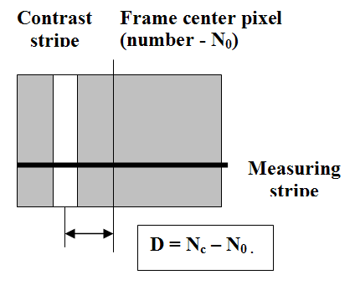

Fig. 3.1 Principal idea of the algorithm

The optical sensor should estimate size D, representing displacement of the white stripe center from the image center. The displacement D is calculated with the method of center of mass.

$D=N_{c}−N_{0}$$N_{c}=\frac{\sum_{i=0}^{n}{L_{i}}∗i}{\sum_{i=0}^{n}{L_{i}}}$ (3.1)
(3.2).

where Nc – pixel number that corresponds to a white stripe center; Li – brightness of i pixel in a measuring stripe; n – number of pixels (length) of a measuring stripe.
The sensor consists of several measuring stripes which indications are used by the algorithm of the robot control. Sample frame from the robot cam is shown on the fig. 3.2.
Measuring stripes are marked D1-D5. Each measuring stripe has its own parameters: offset from the image center, width and height.
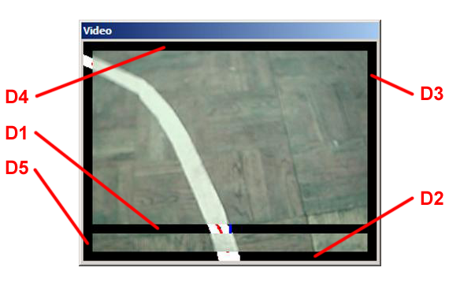

Fig. 3.2 Sample frame from the robot’s cam

Considering the experiments’ results, we added simple threshold filter to measuring stripes of the optical sensor. Somehow that allows putting off flares in sunny day.
During the showing stage of the “teaching by showing” methodology, the robot was controlled by PID-regulator. Throughout this stage, all indications of the measuring stripes D1-D5 were logged. Lately, these indications were used to calculate proper weights for the neural network with MathCad 11.0.
Experiments have approved, that the robot controlled by a neural network ran along the test path with confidence. During the tests one interesting fact was revealed: the control system is very sensitive to camera position. This phenomenon is illustrated by the figure 3.3. We can see a contrast stripe and two fields of view upon different cam fixation angle. It is evident, that two different areas of the stripe are observed. It is clear, that D indications will have opposite signs.
In general case, that means that robot has to be equipped by the cam fixation angle sensor. It can be implemented using hardware sensor or image processing.
During the tests the algorithm has shown good working capacity. Speed of the algorithm is at very high level that allows writing it even to low-performance microprocessors.

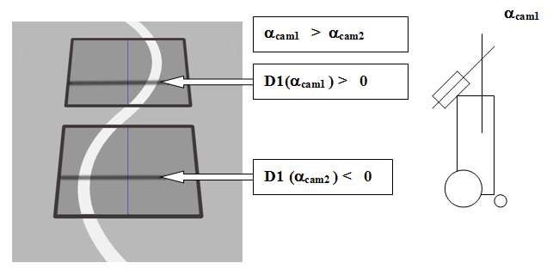
Fig. 3.3 Two different fields of view

IV. IMAGE GENERATOR WITH VIRTUAL REALITY TECHNOLOGY

It can be outlined that real experiment with real robot, that was designed to be as simple as possible still is very expansive in sense of team time to get a set of pictures. In parallel with described above experiments possibility to use virtual reality technology was investigated.
As legend for this part project a trace for robot competition that takes place in the Lomonosov MSU was used. One of discipline in this competition is a race of robot along white stripe. The typical environment where the race takes place is shown on fig.4.1. The landscape dimensions are 6x10m, so it was impossible to reconstruct the ground within the of the student project budget.
Image generator was developed as a part of project. Developed software provides possibility to change dimensions of the ground and texture, change the virtual cam position, slope, to control robot (cam) position and to record movie during the virtual robot movement. During this action, the virtual robot is controlled using standard game joystick.
Virtual robot equipped by cam can move in different modes:
- free ride mode;
- path recording mode;
- replay path mode;
- riding with noise;
- cam position change: height and angle of slope;
- screen capturing mode: 25 fps in a BMP format.
Position of the robot is calculated according to joystick’s tilt. The model of the robot is shown on the fig. 4.2.

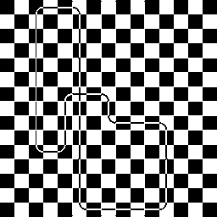
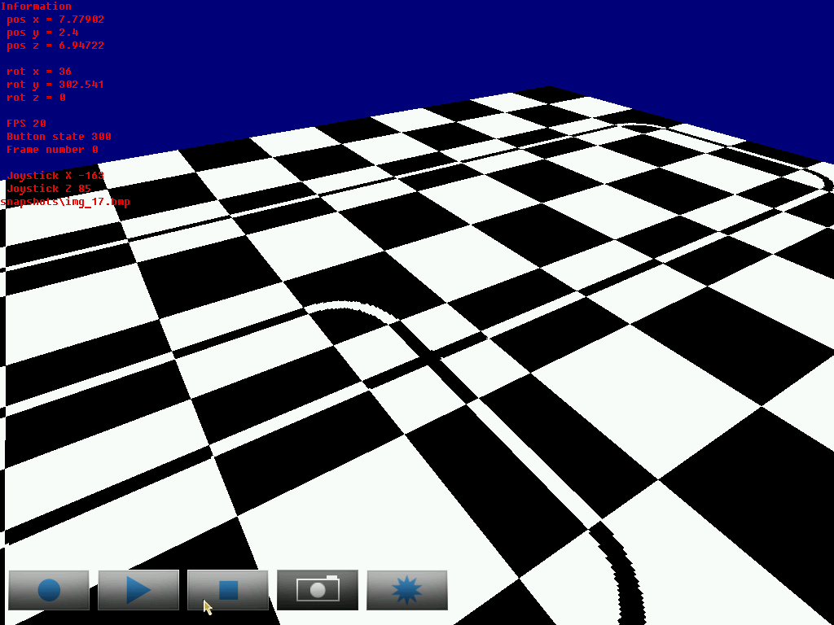
a) Landscape top view

b) Example image from virtual cam

Fig. 4.1 Virtual environment

z
x
y
V
P_{t}
P_{t+1}
α
Fig. 4.2 Model of the robot

Joystick’s tilting on y-axis gives information about speed vector - V, and x-axis tilting represents direction for further movement (α_{t} angle). Speed vector modulus depends only on tilt:

|V| = А_{V}∙∆, (4.1)

where V – speed vector; А_{V} – maximum increment of speed vector modulus; ∆y –у-axis tilt, -1≤ ∆y ≤ 1.
Direction changes only when x-axis tilt present:

α_{t+1} = α_{t} + Аα ∆x, (4.2)

where α_{t+1} – movement direction in the next point of time; α_{t} movement direction in the current point of time (now); Аα – maximum angle change; ∆х – x-axis tilt, -1≤ ∆х ≤ 1.
Movement adjustments are made with entering maximum values of change of course and position. Robot’s position in the next point of time can be found as: (4.3)

P_{t+1} = P_{t} + V_{t} * ∆t, (4.3)

where P_{t+1} = (x _{t+1}, y _{t+1}) – robot’s position in the next point of time;P_{t} = (x _{t}, y _{t}) – robot’s current position; V_{t} – current speed vector.
Z coordinate is constant, because it represents camera’s altitude.

V. CONCLUSION

In early experiments, only five measuring stripes were used. In terms of one step teaching procedure it means we calculated five weights for neural network inputs. What is the maximum number of weights we can calculate? We will answer this question during the “Phoenix-2” research project.
Some tests were made. The limit for MathCAD 11 is 4096 weights (theoretically). It was unable to get reasonable results using 4096 weights, only about 1200 weights could be tested. Time needed for calculation is 40 minutes roughly. Matlab 7.0 has shown better flexibility: working time to get 1200 values is 10 seconds. The maximum of weights depends on amount of memory installed on a PC. On 32-bit platforms (with 2 GB of memory available for Matlab), the number of weights is near to 6000.
Figure 5.1 shows an experiment’s results. 74 sample frames were taken, 54 of them were used to teach a neural network with one step teaching procedure. Frames 55-74 are test sequence – to check how efficiently our neural network works.
The solid line is logged values and the dashed one is the output of our neural network. It is evident, that error value is very small on frames 1-54 and greatly increases on test frames (55-74). The reason for this is insufficient amount of weights (2352, corresponds to image resolution 56x42).

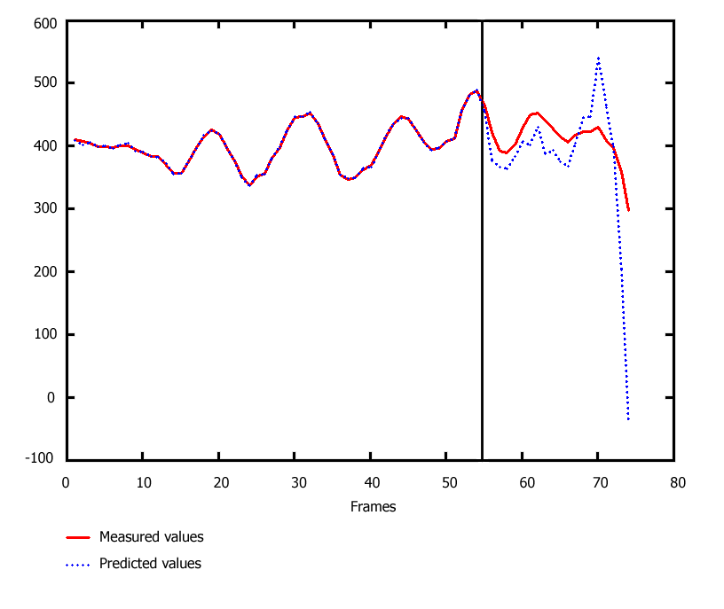

Fig. 5.1. Measured and predicted values

ACKNOWLEDGEMENTS

The authors would sincerely like to thank staff of Student Design Center (SUAI) for support of our work, also as Astapkovich D. and Goncharov A. (team members) for presented materials used in this work.

LIST OF PUBLICATION

- Industrial lication of neural networks , edited by Lakhmi C.Jain, V.Rao Vemuri CRC Press LLС, Boca Raton, London, New York, Washington, D.C ,1999.
- Astapkovitch A.M. Оne step learning procedure for neural net control system. Proc. International forum “Information systems. Problems, perspectives, innovation approaches”, SUAI, Saint-Petersburg, Russia, 2007, p.5-11)
- Тихонов А.Н, Арсенин В.Я. Метеды решения некорректных задач., М., Наука,главная редакция физико-математической литературы, 1979, с. 286.
- Д.А.Астапкович, А.А.Гончаров, А.С.Дмитриев, А.В.Михеев. Проект “Робот Феникс-1”. Сборник докладов пятьдесят девятой международной студенческой научно-технической конференции ГУАП., Часть I, Технические науки, 18-22 апреля 2006, г,Санкт-Петербург, с.211-216.
- Goncharov A. Experimental Integrated Development Environment “Constructor A3” Proc. International Seminar “Challenges of the information age in the field of education”, SUAI, Saint-Petersburg, Russia, 2006, p.36-41)

