CALCULATION OF THE ELECTRIC FIELD DISTORTION IN FREE SPACE DUE TO APPEARANCE OF THE OBJECT WITH CONDUCTIVE SUREACE

Gennady Jatchevitch, Ph.D

Saint-Petersburg State University of Aerospace Instrumentation,
Saint-Petersburg, Russia

Abstract

For the development alarm systems, using the electrostatic field, it is necessary to evaluate the electric field distortion due to appearance of the object with conductive surface. We introduce the concept of the electric field distortion as the deflection of the electric field intensity vector E at each point of the check space due to appearance of the object with conductive surface [1].
We examine four cases:
- Free space with the uniform electric field, the object is right circular cylinder with the conductive side surface of infinite extent.
- Free space with the point electric charge, the object is plane conductive surface of infinite extent.
- Free space with the electric dipole, the object is plane conductive surface of infinite extent. The axis of the dipole is paralleled to the surface.
- Free space with the electric dipole, the object is plane conductive surface of infinite extent. The axis of the dipole is perpendicular to the surface.
On the first case we solve the Laplace’s equation in cylindrical coordinates and use the boundary conditions on the conductive surface of the cylinder. For the second, the third and the fourth cases we use the method of images.

I. FREE SPACE WITH THE UNIFORM EXTERNAL ELECTRIC FIELD AND THE OBJECT IS RIGHT CIRCULAR CYLINDER WITH THE CONDUCTIVE SIDE SURFACE OF INFINITE EXTENT

In order to calculate electric field strength vector it is necessary to solve Laplace’s equation in cylindrical coordinates [2], [3] fig (1.1)

Laplace’s equation is

$\text{ΔΦ}=\frac{1}{ρ}⋅\left[\frac{∂}{∂ρ}⋅\left(ρ⋅\frac{∂Φ}{∂ρ}\right)+\frac{∂}{∂φ}⋅\left(\frac{1}{ρ}⋅\frac{∂Φ}{∂φ}\right)+\frac{∂}{∂z}⋅\left(ρ⋅\frac{∂Φ}{∂z}\right)\right]=0$, (1.1)

where Φ – is potential at the check point of the space.

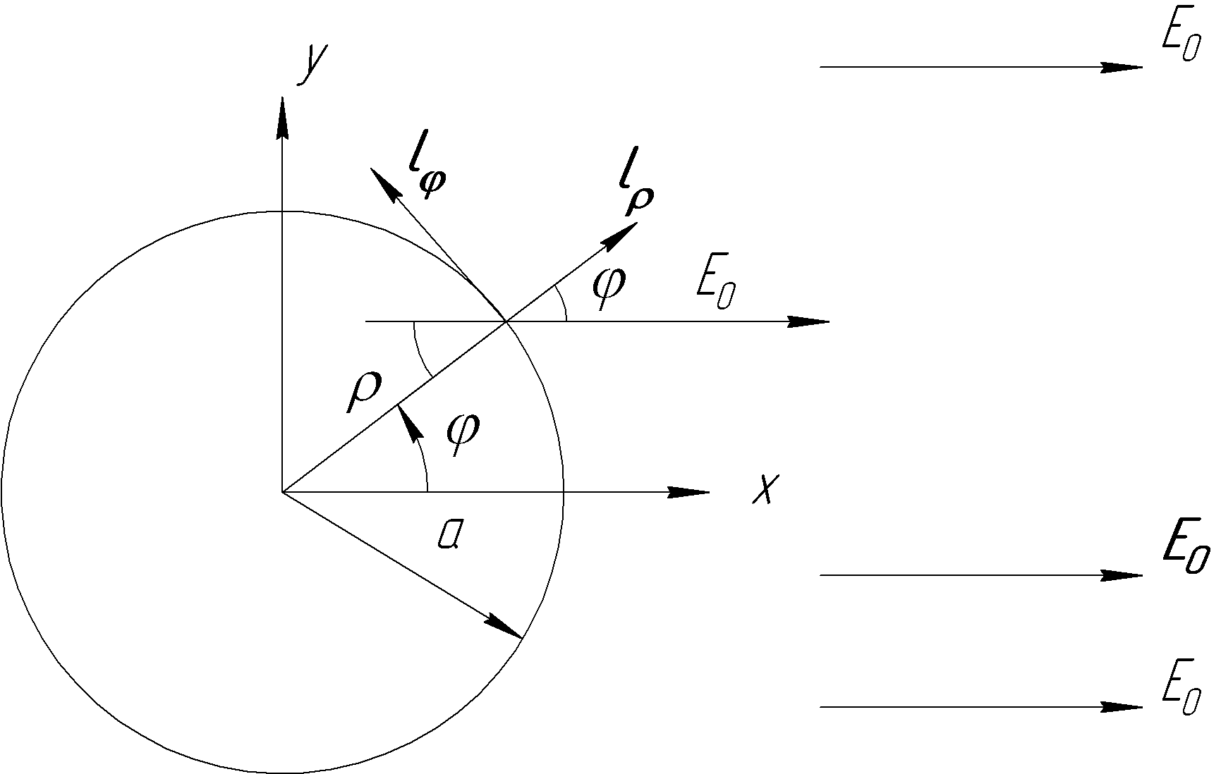

Fig.1.1 Uniform external electric field and the object

As potential φ doesn’t depend on Z coordinate, we have

$\frac{1}{ρ}⋅\frac{∂Φ}{∂ρ}+\frac{∂^{2}Φ}{∂ρ^{2}}+\frac{1}{ρ^{2}}⋅\frac{∂^{2}Φ}{∂φ^{2}}=0$ (1.2)

Let us assume that potential Φ is equal

, (1.3)

where f₁ depends on coordinate ρ, and f₂ depend on coordinate φ.
Substituting (1.3) into (1.2), we obtain

$f_{2}⋅\frac{1}{ρ}⋅\frac{∂f_{1}}{∂ρ}+f_{2}⋅\frac{∂^{2}f_{1}}{∂ρ^{2}}+f_{1}⋅\frac{1}{ρ^{2}}⋅\frac{∂^{2}f_{2}}{∂φ^{2}}=0$ (1.4)

After separating variables we have
$\frac{ρ}{f_{1}}⋅\frac{∂f_{1}}{∂ρ}+\frac{ρ^{2}}{f_{1}}⋅\frac{∂^{2}f_{1}}{∂ρ^{2}}=ρ^{2}$
$\frac{−1}{f_{2}}⋅\frac{∂^{2}⋅f_{2}}{∂φ^{2}}=p^{2}$, (1.5)

where p – is constant.

In our case

(1.6)

Consequently

(1.7)

Let us introduce the new variable ω such that

(1.8)

Then we have

(1.9)

(1.10)

Common integral of this equation

(1.11)

and function f₁ become

(1.12)

Unknown potential Φ equals

(1.13)

Therefore the components of electric field are

(1.14)

(1.15)

For cylinder doesn’t affect upon the electric field, therefore

$A_{1}=−E_{0}$ (1.16)

For cylinder surface ρ=a
The components of electric field are given by the following formulas

(1.17)

(1.18)

The components of electric field $E_{0}$ for the free space are

(1.19)

(1.20)

And distortion of the electric field is the deflection of electric vector

E=E_{ρ} .e_{ρ}+ E_{φ} .e_{φ} (1.21)

relatively vector E₀

E₀=E_{ρ1} .e_{ρ}+ E_{φ1} .e_{φ} (1.22)

Angle of deflection α is given by the following formula [2]

The results of calculation with the help of Matlab 7.0 are illustrated on fig. 2.1, where x=ρ/a, y~Φ
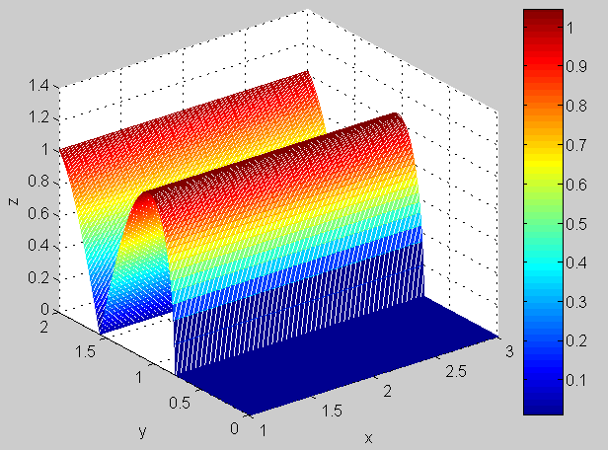
Fig.1.2 Angle of deflection Z due to X, Y

II. FREE SPACE WITH THE POSITIVE POINT CHARGE, THE OBJECT IS PLANE SURFACE OF INFINITE EXTENT

This case is illustrated on fig. 2.1
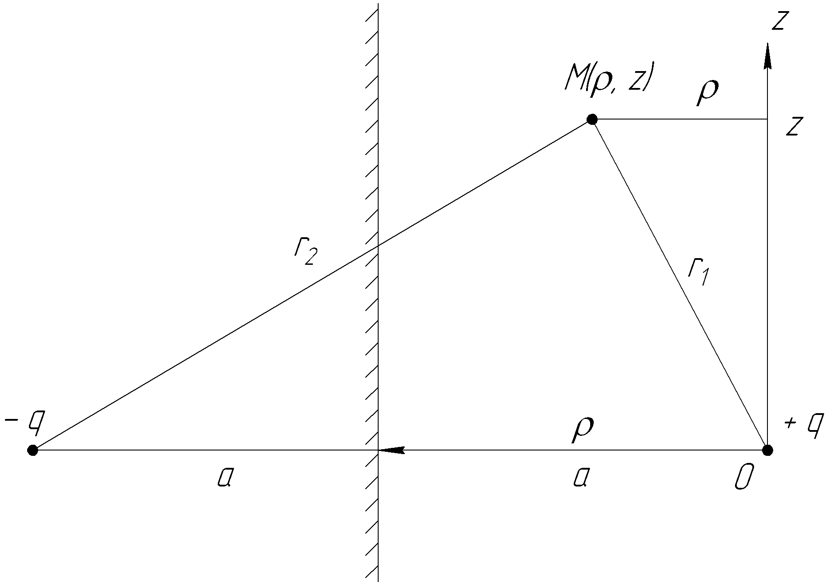
Fig. 2.1 Positive point charge and the object in free space

The potential of the paint M (ρ,z) fig 2.1 in free space

, (2.1)

where E_{a} – capacitivity of the medium.
The components of electric field vector is equal to [2],[3],[4]

(2.2)

(2.3)

After appearance of the object potential at the point M(ρ,z) of system of point charge is equal to the sum of the potential created at a given point by each of the charges [2] The potential at the point M(ρ,z) is given by

(2.4)

And the components of electric field will be

(2.5)

(2.6)

Using Eq.(2.2), (2.3), (2.5) and (2.6) we can write [2]

(2.7)

After calculating with the help of Matlab 7.0 we have the results which are illustraited on fig 2.2, where x=ρ/a, y=z/a

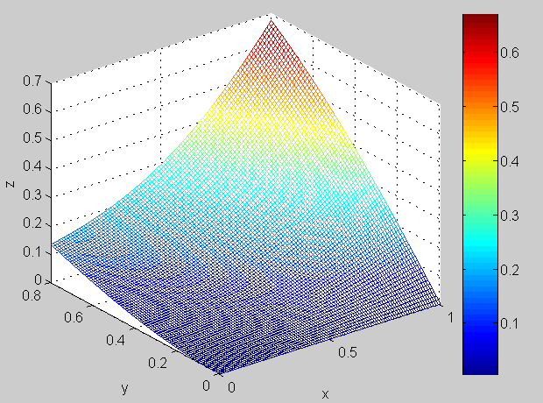
Fig2.2 Angle of deflection Z due to X,Y

III. FREE SPACE WITH THE ELECTRIC DIPOLE, THE OBJECT IS PLANE CONDUCTIVE SURFACE OF INFINITE EXTENT WHICH IS PARALLELED TO THE AXIS OF THE DIPOLE.

This case is illustrated on fig 3.1.
Potential at the point M in free space [2]

(3.1)

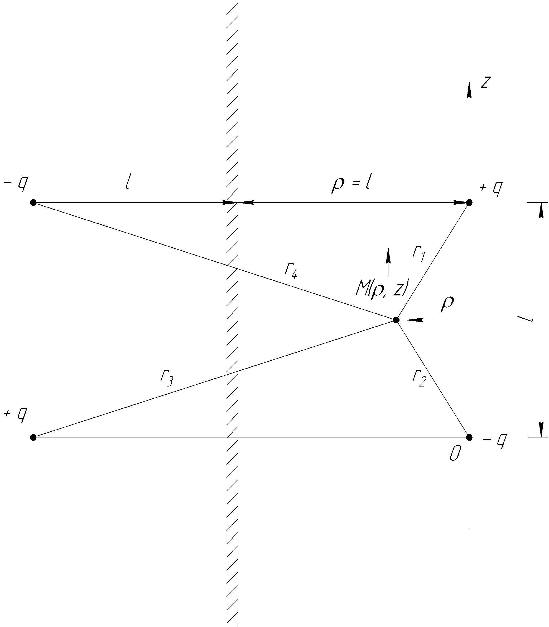

Fig.3.1 Electric dipole in free space and the object

The components of electrical field vector are equal to

(3.2)

(3.3)

After appearance of the object (fig 2.1) the components of electric field vector are equal to

(3.4)

(3.5)

Using Eq. (3.2), (3.3), (3.4) and (3.5) we can write [2]

(3.6)

After calculating Eq. (3.6) with the help of Matlab 7.0 we have the results which are illustrated on fig. 3.2, where x=ρ/a, y=z/a

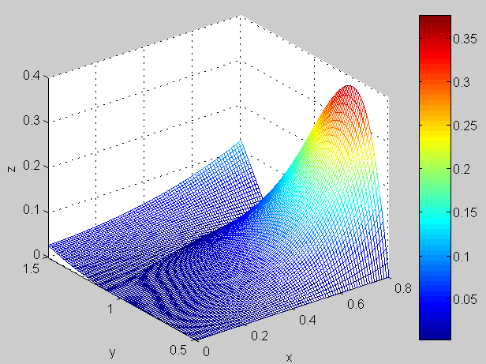

Fig.3.2 Angle of deflection Z due to X,Y

IV. FREE SPACE WITH ELECTRIC DIPOLE, THE OBJECT IS PLANE CONDUCTIVE SURFACE OF INFINITE EXTENT. THE AXIS OF THE DIPOLE IS PERPENDICULAR TO THE SURFACE
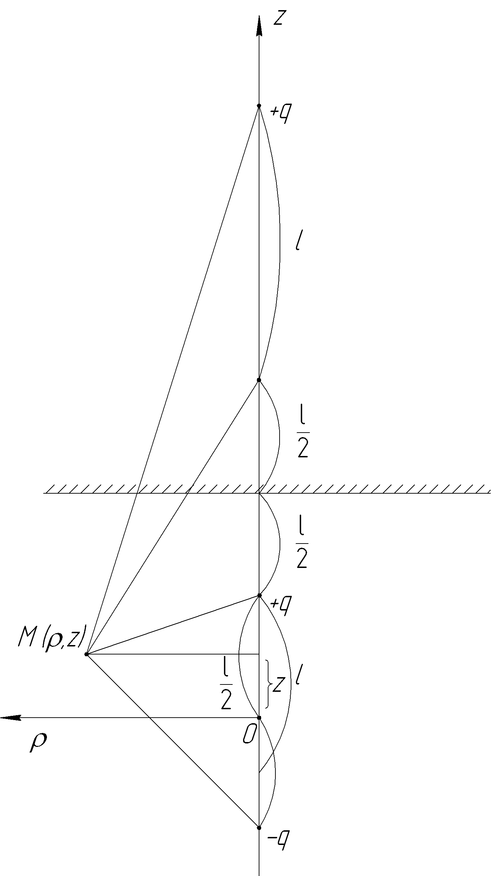
Fig.4.1 Electric dipole and the object
This case is illustrated on fig 4.1. In free space the components of electrical field vector are equal to

(4.1)

(4.2)

After appearance of the object (fig 4.1) the components of electric field vector are equal to

(4.3)

(4.4)

Using Eq (4.1), (4.2), (4.3) and (4.4) we can write

(4.5)

After calculating Eq (4.5) with the help of Matlab 7.0 we have the results which are illustrated on fig 4.2, where x=ρ/a, y=z/a

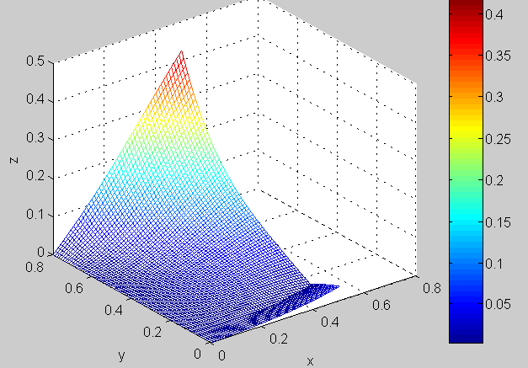

Fig.4.2 Angle of deflection Z due to X,Y

V. CONCLUSION

The received results are preliminary and have conceptual meaning.
Preliminary results show that the value of distortion at the check point of the space depends on the distance from check point to the object, on orientation of the object, and position of check point in the free space.
The received results prove the possibility of development alarm system using electrostatic field.
We developed the transducer of electric field distortion and we investigated experimentally the deflection of the electric field intensity vector at the same check points, that performed theoretically, due to appearance of the object of finite sizes and we had the confirmation of calculation results.
But these results are topics of the another articles.

REFERENCES

- Яцевич Г.Б. Варжапетян А.Г. Устройство охранной сигнализации. Свидетельство на полезную модель №23511 от 20.06.2002г.
- Smyth W.R. Static and dynamic electricity. New York-Toronto-London 1950.
- Стрэттон Дж. А. Теория электромагнетизма. М.1949г.
- Matveev A.N. Electricity and Magnetism Mir,1986.

