DEVICE FOR INDIRECT METHOD OF CONTROLLING PHASE
OF HARMONIC SIGNAL

Odundo Simon Ochieng

Saint-Petersburg State University of Aerospace Instrumentation,
Saint-Petersburg, Russia

Abstract
Modern mobile communications involving the use of wireless communication suffers from the effect of multi-path fading.
This problem has created a need for electronically controllable phase shifters that are inexpensive and simple to produce.
This paper discusses an alternative possibility of realizing controlled phase-shifting device using mathematical method.

Keywords: phase shifter, phase shift, phase displacement, phase angle.

I. INTRODUCTION

Phase shifter is an electronic device whose output voltage (or current) differs from its input voltage (or current) by some desired phase relationship. In some devices, the phase is shifted a fixed amount because of an inherent design feature, but in others the phase relationship can be adjusted.
Figure 1. Below is an example of common phase shifter using operational amplifier (OA).

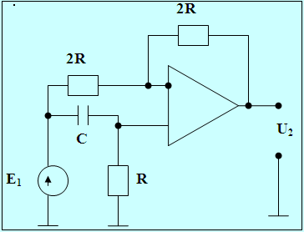

Fig. 1. Diagram of a phase shifter

The input signal passes though the operation amplifier (OA) by two paths;
First through the resistor 2R and the inverting input of OA with amplifying factor, as

$K_{\text{AMP}\text{.}}=−\frac{2R}{2R}=−1$. (1)

The second path through the CR circuit and non-inverting input of OA with transmission efficiency as.

$K(jω)_{\text{Tran}\text{.}}=\frac{2R}{R+\frac{1}{jω}}$ (2)

Therefore transmission efficiency of this circuit is;

$K{\left(jω\right)}_{\text{Tran}\text{.}}=\frac{U_{2}}{E_{1}}=−1+\frac{2R}{R+\frac{1}{jωC}}=\frac{jω\text{RC}−1}{jω\text{RC}+1}$ (3)

From (3) it is clear that by changing frequency ω from 0 to ∞, the module does not change; K (ω) _{Tran.} =1, but phase changes from $−π$ to$−2π$. But if we change the place of C and R by each other then,

$K{\left(jω\right)}_{\text{Tran}\text{.}}=\frac{1−jω\text{RC}}{1+jω\text{RC}}$ (4)

In (4) above, for ω Є [0; ∞]; the module is also is K (ω) _{Tran.} =1, but phase changes from 0 to$−π$
The main disadvantages of this device are as follows:
- Low accuracy of the given controlled phase.
- Limited function capability, this is connected with the fact that, in this phase shifter the value of phase shift is computed by the value of elements and also the value controlled phase. That is to say that frequency and phase of signal are depended which is not good for controlling phase.

II. WORKING SYSTEM

This method is based on a common mathematical equation under trigonometric function of harmonic character written as.

$А⋅а\text{sin}ωt+B⋅a\text{cos}ωt=a\sqrt{A^{2}+B^{2}}\text{sin}(ωt+ϕ)$, (5)
where ϕ = arc tan ($\frac{A}{B}$). Known as phase angle

This expression can be explained using the diagram below:

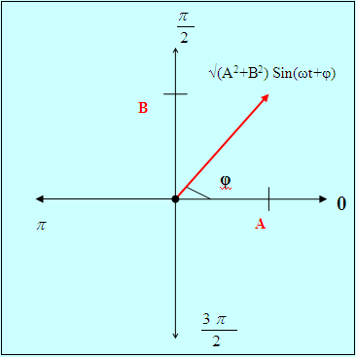

Fig. 2. Graph of harmonics

It is clear that we can calculate different phase angles ϕ by changing A and B.
Equation 5 can also be presented as show below:

$А⋅а\text{sin}ωt+B⋅a\text{cos}ωt=a\sqrt{A^{2}+B^{2}}\text{cos}(ωt−ϕ)$, (6)
where ϕ = arc tan ($\frac{A}{B}$).

Consider an input signal as

U (t) _{input} = aSinωt. (7)

Then by running it through a given transformation circuit such that its output will be equal to its cosine by frequency and amplitude as

U (t) _{Tran. out} = aCosωt. (8)

By amplifying (7) and (8) above by A and B respectively then get there sum we form (6) as shown below

$А⋅а\text{sin}ωt+B⋅a\text{cos}ωt=a\sqrt{A^{2}+B^{2}}\text{cos}(ωt−ϕ)$, (9)
where ϕ = arc tan ($\frac{A}{B}$).

Through dividing (9) by $\sqrt{A^{2}+B^{2}}$ we get a harmonic signal that has the same amplitude its input but phase shifted depending on the value of A and B written as:

U (t) _{output} =aCos (ωt-φ), (10)
where ϕ = arc tan ($\frac{A}{B}$).

Below is the block diagram of indirect method of phase displacement.

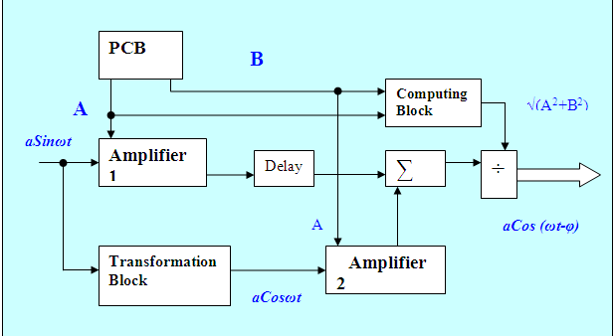

Fig. 3. Device for indirect method of phase controlling

Phase Control Board (PCB).
Phase control board marked in fig. 2 above as PCB; allow controlling the output phase displacement by changing both the values of A and B depending on the desired output phase shift.

Computing Block
It calculates the square root of the sum of square of A and B from PCB every time we change the code A and B are changed.

$\sqrt{A^{2}+B^{2}}$ (11)

Transformation Block
Transforms the input sinusoid signal to cosine through differentiation and the dividing it with the value equivalent to the input signal frequency as shown below:

$u(t)^{\text{diff}\text{.}}=\frac{\text{du}(t)_{\text{input}}}{\text{dt}}=ωа\text{cos}ωt$ (12)

$u(t)_{\text{Tran}\text{.}\text{output}}^{\text{diff}}=\frac{ω\text{.}a\text{cos}ωt}{ω}=а\text{cos}ωt$ (13)

Amplifiers
This device contains two amplifiers which amplifies both sine and cosine harmonic with the value equivalent to code A and B respectively.

Delay
It holds the input sinusoid signal so that both sine and cosine harmonic to reach to the adder at the same time.

Adder
Gets the sum of sine and cosine harmonics after amplification as

$А⋅а\text{sin}ωt+B⋅a\text{cos}ωt=a\sqrt{A^{2}+B^{2}}\text{cos}(ωt−ϕ)$, (14)
where ϕ = arc tan ($\frac{A}{B}$).

Divider
Divides the output of adder (14) with the output of computing block in order to obtain an output signal with the same amplitude as the input signal as in (11).

The diagram below shows indirect method of phase displacement using MATLAB stimulation.

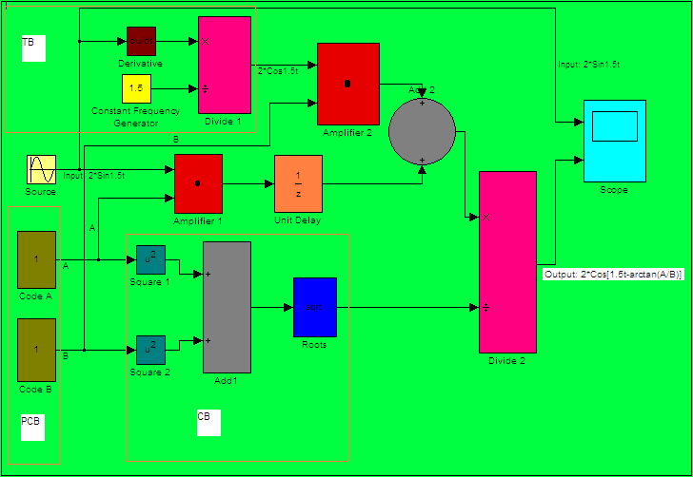

Fig. 4. Device for indirect method of controlling phase using MATLAB stimulation
{TB-Transformation block, PCB-Phase Control Board, CB-Computing Board}

Constant frequency generator (CFG)
CFG as its name generates fixed frequency at all time as shown in fig.4 below. The value of fixed frequency must be equal to input signal frequency in order to divide the signal from the differentiator as in (13).
In this case I used an input signal as

U (t) _{input} = 2*Sin1.5t. (15)

Hence frequency of CTG is ω =1.5 rad/sec.
This is also same as

f=$\frac{ω}{2×π}$=2.39*10⁻¹ Hz.

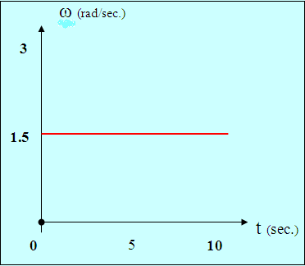

Fig.5. Frequency-time characteristic of CFG

III. RESULTS

I obtained the following results using Mathlab stimulation shown in fig.4 for various values of A and B.

For A=B; φ= arc tan | For A=17.3 and B=10; φ=arc tan$\left(\frac{A}{B}\right)={\text{60}}^{∘}$
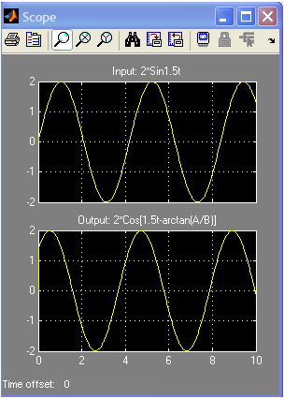 | 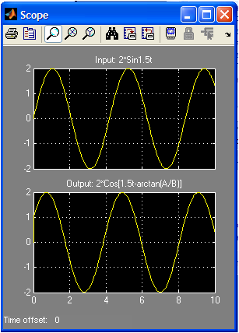
For A=0 and B=1; φ= arc tan$\left(\frac{A}{B}\right)=0^{∘}$ | For A=1 and B=0; φ= arc tan$\left(\frac{A}{B}\right)={\text{90}}^{∘}$
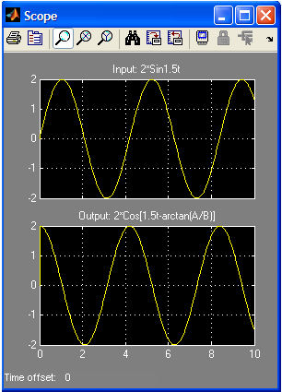 | 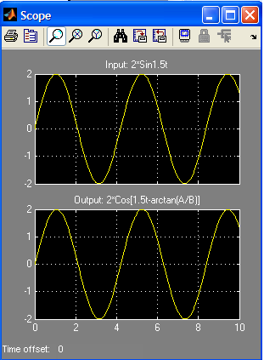

Using the result obtained, it is possible to draw phase characteristic of the device above fig.4, i.e. output (phase shift) against input ($\frac{A}{B}$) graph as shown in fig.6 below.
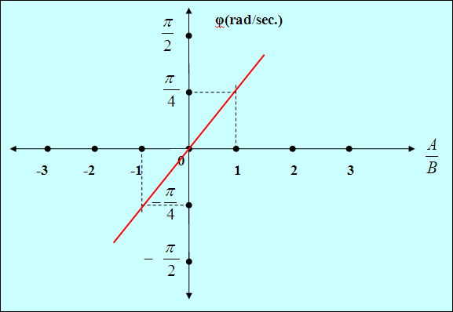

Fig.6. Output-Input characteristic for the device for controlling phase.

IV. CONCLUSION

- This method enables to realize phase displacement of harmonic signal from -π/2 to π/2 as shown by the result obtained [3].
- Phase shift is obtained through ‘arctangent’ which is a linear dependence as shown in fig. 6 i.e. a linear phase system.
- This device also allows controlling phase of harmonic signal within a large range of frequency.
- Higher accuracy of phase displacement is realized, which depends only on code A and B
- The algorithm used for building the phase shifter does not dependent on frequency and parasitic amplitude which also improves accuracy.

V. REFERENCES

- Двайт. Математические формулы и выражения. М.: Высшая школа.
- А.Г. Зюко, Д.Д. Кловский, В.И. Коржик, М.В. Назаров. Теория электрической связи. Учебник для вузов/ Под ред. Д.Д. Кловского. – М.: Радио и связь, 1998. – 442 с.: 204 ил.
- В.И. Кириллов. Многоканальные система передачи. Москва ООО<<Новое здание 2002>>.
- The Automation, System, and Instrumentation Dictionary. 4th Edition.
- Richard Read. THE ESSENCE OF Communication Theory. Prentice Hall.

