THE PARALLEL SPECTRUM ANALYZER OF OPTICAL SIGNALS

Mikhail Vaganov

Saint-Petersburg State University of Aerospace Instrumentation
Saint-Petersburg, Russia

ma.vaganov@gmail.com

Abstract

The parallel spectrum analyzer of optical signals is presented in this paper. This device is one of spectral devices which receive spectroscopic information in an optical range.
The considered spectrum analyzer can make parallel analysis of spectrum of optical radiations which are in places of difficult access, for instance, in unfavorable conditions of high humidity, high temperature and toxic contamination. The result is achieved due to specific structure of the analyzer which contains n channels of spectrum analyzer and the group of optical fibers which transmits analyzed optical radiation on the given distance.

I. INTRODUCTION

Receiving spectroscopic information by the known modern spectral devices is based on the spatial processing of analyzed optical radiation. This method of receiving spectroscopic information requires a precise alignment and a rigid construction that considerably increases mass and sizes of device.
The spectral device considered in this paper carries out spectral decomposition based on the resonance phenomenon, i.e. the spectral decomposition is implemented by the principle of the narrow-band optical filtration in n parallel channels [1]. Each channel contains the narrow-band optical filter (resonator) which has been set on the certain wave length.
In contrast to the traditional spectral devices, this device can make parallel analysis of optical radiation spectrum, excepting a direct contact with the field of radiation sources. The group of optical fibers realizes the function of transmitting analyzed optical radiation on the given distance.

II. METHODS OF SPECTRUM ANALYSIS IN AN OPTICAL RANGE

The great amount of various types of spectral devices is used in the field of spectroscopic measurements in an optical range. These devices differ by the method of spectral decomposition, the method of recording spectrum and the specificity of their construction. Their differences depend on the studied spectral range and their intended purpose [2].
In this paper the comparison of spectral devices is based on the method of spectral decomposition of the optical radiation.
Classical spectrometers find a wide application in the optical spectroscopy. These devices carry out spectral decomposition of an optical radiation in the space. Diffraction grating or dispersive prism is used as the dispersive element for spectral decomposition, which splits and diffracts light into several beams travelling in different directions. The directions of these beams depend on the wavelength of the light [3]. At present spectrometers based on the acousto-optic modulator find wide application too. An acousto-optic modulator uses the acousto-optic effect to diffract and shift the frequency of light using sound waves.
A simple schematic of the classical spectrometer is shown in Figure 1. It consists of a light source, a lens, a slit, a collimating lens 1, a dispersive element, a collimating lens 2 and a focal plane.
The dispersive element separates and deviates the bundles of parallel light of different wavelengths. The number of parallel beams is determined by a set of wavelengths of light present in the light source. Then parallel beams are focused on the focal plane by the collimating lens 2

Fig. 1. The schematic of the classical spectrometer

Spectrometers can make both sequential and parallel spectrum analysis of optical signals. When analysis is sequential one photo detector is used for detection analyzed optical signals and studying spectrum is implemented by rotation of the dispersive element or in the case of acousto-optic modulator by changing acoustic frequency. When analysis is parallel the spectral decomposition of an optical radiation in the space takes place and a set of photo detectors or CCD structure is used for detection analyzed optical signals.
Receiving spectroscopic information by the known modern spectral devices is based on the spatial processing of analyzed optical radiation. This method of receiving spectroscopic information requires a precise alignment and a rigid construction that considerably increases mass and sizes of device which are a very important criterion for designing devices for aircrafts.
Furthermore the resolution of classical spectrometers depends on slit size. The smaller the slit size is the better the resolution is.
But energy of the analyzed signal decreases with slit size too. Especially “problem of slit” is topical when the multimode optical fiber is used for transmitting the analyzed optical signal [2].
In addition, classical spectrometers have one more disadvantage. It is a necessity of using the preliminary monochromator or order sorting filter to select narrow range of spectrum for reduction of the 2nd order effects on results of measurements.
The spectrum analyzer considered in this paper carries out spectral decomposition based on the resonance phenomenon, i.e. the spectral decomposition is implemented by the principle of the narrow-band optical filtration in n parallel channels. Each channel contains the narrow-band optical filter (resonator) which has been set on the certain wave length. A simple schematic of the parallel spectrum analyzer is shown in Figure 2. It consists of a light source, a lens, a group of optical fibers; n channels of the spectrum analyzer and a focal plane.

Fig.2. The schematic of the parallel spectrum analyzer

This device may be marked out in individual class of spectrum analyzers because of unconventional method of spectrum measurements. It is confirmed by obtained patent № 86734 of the Russian Federation [1]. Particular construction of this device doesn’t require a precise alignment and a rigid construction that allows designing spectrum analyzer which will satisfy exacting requirements to mass and sizes of device. Furthermore the “problem of slit” is non-topical because spectral diagram is defined by the passband of optical filters.
The most important advantage of this device is its ability to make spectrum analysis of sources of optical signals which are in places of difficult access, for instance, in unfavourable conditions of high humidity, high temperature, high explosibility and toxic contamination. The optical fibers are used for excepting the direct contact device with the source of optical radiation and transmitting analyzed signals on the safe place for spectrum analyzer.
Due to unconventional method of spectrum analysis, the multimode propagation phenomena of optical signal in an optical fiber which is used for transmitting an optical signal has no an influence on results of spectrum measurements.

III. THE PARALLEL SPECTRUM ANALYZER OF OPTICAL SIGNALS

The block diagram of the parallel spectrum analyzer of optical signals is shown in figure 3.
The spectrum analyzer consists of: an input lens 1; a group of optical fibers 2; the first collimating lens 3; an optical filter 4; the second collimating lens 5; spectroscopic information processing block 6; recording system 7. Blocks 3, 4 and 5 are the channel of the spectrum analyzer [4].

Fig. 3. The block diagram of the parallel spectrum analyzer of optical signals

The operation of the parallel spectrum analyzer of optical signals is described as follows: An input lens transmits optical radiation from surroundings to the common input of the group of optical fibers which is situated in focal length of the input lens. The group of optical fibers is used for transmitting optical radiation at the given distance. The optical radiation passed through the group of optical fibers is transmitted to the first collimating lenses for the further spectral decomposition. The first collimating lens transforms divergent beam of light which is transmitted from the output of optical fibers into the parallel beam of light. The optical filter is set on the certain wave length. After optical filtering in the each channel of the spectrum analyzer by the optical filters from the second collimating lenses the parallel beam of light is focused on the photodiodes which are inputs of the spectroscopic information processing block. Then optical radiation transforms in the electric signal. After digital processing spectroscopic information displays on the recording system. The oscillograph is used as a recording system.
The mission of the spectroscopic information processing block is reading signal levels from each channel of the spectrum analyzer, and in displaying of the spectroscopic information about these signals on the oscillograph.
The block diagram of the spectroscopic information processing block is shown in figure 4. This block contains input amplifiers with manual gain control and the amplification block with automatic gain control. The gain control is necessary for compensation of signal distortions coming from photodiodes. Signal distortions are the result of irregularities of optical fiber characteristic, characteristic of filters and sensitivity characteristic of photodiodes. The gain of input amplifiers is set just once by the operator while adjusting. The gain of the amplification block is controlled by the microcontroller.
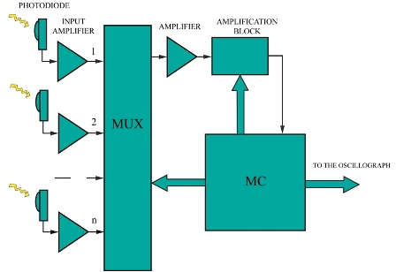

Fig. 4. The block diagram
of the spectroscopic information processing block

The spectroscopic information processing block operates in the following way: signals are transmitted from photodiodes to input amplifiers. The level of each signal depends on intensity of optical radiation on the given wave length. Signals from input amplifiers are transmitted to the multiplexer and are consecutively commuted to its output.
The microcontroller consecutively commutes each input of the multiplexer to its output according to the submitted code by the busbar of multiplexer control. Output of the multiplexer is connected with the amplifier. Also the microcontroller transmits the value of adjustment factor into the first controlled amplifier for setting its gain. The value of adjustment factor is individual for each channel. The microcontroller changes the gain of this amplifier with each switching of multiplexer on the next channel so that signal distortions coming from photodiodes are compensated. Then signals passed throw the first amplifier are transmitted to the second amplifier of the amplification block. It is controlled by the microcontroller too. Its gain depends only on the maximum signal level of all channels. If the maximum signal level is more than the maximum permissible level, the microcontroller automatically decreases the gain of this amplifier until the signal with the maximum level becomes equal to the maximum permissible level. If the maximum signal level is much less than the maximum permissible level, the microcontroller automatically increases the gain of this amplifier until signal with the maximum level becomes equal to the maximum permissible level. This solution simplifies the process of observing the signal and optimizes it for more detailed reading information from photodiodes. After amplification the signal is transmitted to the ADC (analog-to-digital converter) of the microcontroller for digitization. The microcontroller processes this signal and displays the information about the level of each signal on the oscillograph.

IV. THE LABORATORY SET-UP
OF THE PARALLEL SPECTRUM ANALYZER
OF OPTICAL SIGNALS

The laboratory set-up of the parallel spectrum analyzer of optical signals was developed and realized in the laboratory of optical-acoustic devices of the Saint-Petersburg State University of Aerospace Instrumentation. This device realizes ideas of patent № 86734 of the Russian Federation [1].
The input lens 1, the group of optical fibers 2, three channels of the spectrum analyzer 3 and the spectroscopic information processing block 4 were realized within the limits of the research work.
The photograph of the operating laboratory set-up of the parallel spectrum analyzer of optical signals is shown in figure 5.

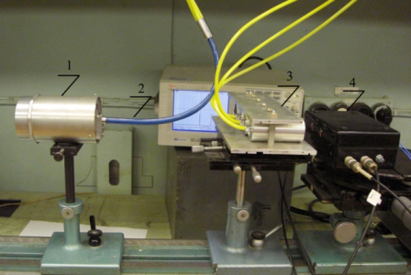

Fig. 5. The laboratory set-up of the parallel spectrum analyzer
of optical signals

When realizing the spectroscopic information processing block photodiodes SILONEX SLSD-71N20 were used.
To prove functionality of the parallel spectrum analyzer of optical signals three channels of the spectrum analyzer were realized within the limits of this experiment. At this moment the preliminary results of the experiment are obtained. A 150 W metal halogen lamp Philips Master Colour CDM-T 150W/942 were used as a source of optical radiation. Received spectral diagram is shown in figure 6.

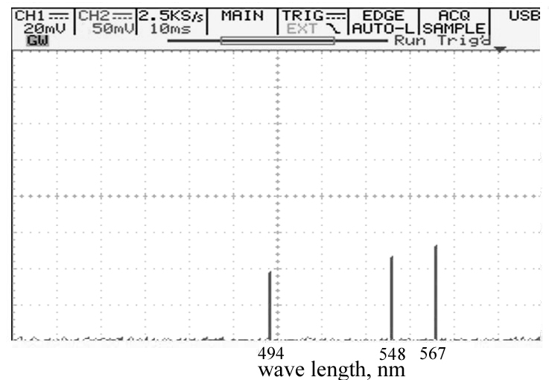

Fig. 6. The spectral diagram of the metal halogen lamp
for three channels of the spectrum analyzer
These results prove functionality of the parallel spectrum analyzer of optical signals.

V. Fields of possible application of the developed spectrum analyzer

The development of the device considered in this paper is directed to solve the problem of receiving spectroscopic information in an optical range from sources of optical signals with which the direct contact is impossible or undesirable. In the first place it is necessary for analyzing such radiation sources as a flame in the jet engine. The received spectroscopic information allows predetermining a state of the jet engine to prevent a plane crash which can happen because of its destruction. Appearance of spectral lines of engine’s materials such as Fe, C and alloy additives in the radiation spectrum of the flame is the first sign of the crash.
The developed spectral device also can be used for control and management of the technological processes proceeding in unfavorable conditions of high humidity, high temperature and toxic contamination, for example, in textile industry, in metallurgy industry for continuous control of technological process - producing steel, and also for optimization of combustion processes in fire chambers of heat-power installations.

VI. CONCLUSION

The parallel spectrum analyzer of optical signals with transmission of analyzed signals with using the optical fiber has been considered in this paper. Due to unconventional method of spectrum measurements this device may be marked out in individual class of spectrum analyzers. The made comparative analysis has demonstrated that considerable part of disadvantages belonged to classical spectrometers are eliminated by the developed parallel spectrum analyzer.
Presented fields of possible application of the developed device prove necessity of these scientific researches. At this moment the laboratory set-up of the parallel spectrum analyzer of optical signals was developed within the limits of the research work and the preliminary results of its experimental research have been obtained. These results prove functionality of the parallel spectrum analyzer.
Successful creation of such devices depends on development of technology which allows to making optical filters with enough narrow filter passband.

REFERENCES

- Moskaletz, O.D., Vaganov, M.A., Kulakov, S.V., Preslenev, L.N., Arkhipov, I.N., Kotlikov, E.N. and Prokashev, V.N.. Parallel spectrum analyzer of signals of optical range. Patent of Russian Federation № 86734, 2009;
- Malishev, V.I. Introduction to experimental spectroscopy. The Publishing House of the Science. Moscow. P. 478, 1979;
- Tarasov, K.I. Spectral devices. The Publishing House of the Mechanical engineering. Leningrad. P. 388, 1977.
- Vaganov, M. A., Moskaletz, O. D., Preslenev, L. N., et al.. The parallel spectrum analyzer of optical signals. Proceedings of SPIE Vol. 7797, 77970X, 2010.

