THE NORD STREAM PROJECT

Natalia Pavlova

Saint-Petersburg State University of Aerospace Instrumentation
Saint-Petersburg, Russia

nataliapavlova.98@gmail.com

Abstract

Despite the development of alternative energy, oil and gas are still the most important energy resourses. That is why it was decided to build the Nord Stream, the twin pipeline system through the Baltic Sea that runs from Vyborg, Russia to Lubmin near Greifswald, Germany. The pipelines are built and operated by Nord Stream AG.
The Nord Stream route crosses the Exclusive Economic Zones of Russia, Finland, Sweden, Denmark and Germany, as well as the territorial waters of Russia, Denmark, and Germany.
Construction of Line 1 of the twin pipeline system began in April 2010, and was completed in June 2011. Transportation of gas through Line 1 began in mid November 2011. Construction of Line 2, which runs parallel to Line 1, began in May 2011. The second line is planned to come on stream in the last quarter of 2012. Each line has a transport capacity of roughly 27.5 bcm of natural gas per annum. [1]

- REASONS OF THE NORD STREAM CONSTRUCTION

Construction of the pipeline system was implemented due to a number of reasons. The main ones are presented below:
- increased natural gaz consumption in EU countries;
- demand on the direct supply of raw materials to the consumer ( regardless of the transit countries);
- reduced cost of transported gas (by the supplier-consumer distance decrease and cutback of import payments for transit through neighbor countries);
- environmental safety in the area of the pipeline;
- long-term import contracts after the pipeline connection to the rich deposits of Yamal semi-island (South Russian) and in the Barents Sea (Shtokman).
The Nord Stream pipeline is intended to provide the Russian natural gas to such European countries as Great Britain, Germany, Denmark, the Netherlands and France. In 2005, the Europen demand on gas was 314 billion m³, and by 2025 year, according to the forecast, it should increase to 509 billion m³. Nord Stream, which project capacity is 55 billion m³ per year, will provide approximately 25% of future growth needs.

- THE NORD STREAM TECHNICAL CHARACTERISTICS

Geographically, the Nord Stream pipeline has two land sections and sea one connecting them. The beginning of the gas main is the Gryazovets (Vologda Region) – Vyborg route, 917 km in length, providing the transit of natural gas fields of northern Russia (the owner and developer of the route is “Gazprom” public cooperation).
The second land section is located on the territory of importer countries. It connects the output terminal on the coast of Germany (Lubmin) and OPAL and NEL from Greifswald transport networks with the total length of 850 km, which will provide gas supply to the south and West Germany, with a connection to the EU gas mains. WINGAS and E.ON Ruhrgas were involved in its construction.
One of the key points while creating the Nord Stream project was the optimization of its sea route. Marine research was held from 1997 year to 2008 year. This unprecedented research allowed not only to develop the optimal route of the pipeline under the Baltic Sea but also to understand its ecosystem better.
While the pipeline creation some new safety technology of the pipeline installation on the sea depths were introduced. In particular, the original design solution made it possible not to install an intermediate compression station in the sea section. Moreover, each branch of the pipeline was created of three parts, with pipes of different diameters, which provided a standard operating pressure of 200 atmospheres at the output terminal in Germany.

- THE NORD STREAM PROJECT HISTORY

Prior to its collapse in 1991 year, the Soviet Union was a major supplier of natural gas to Europe (approximately, 110 billion cubic meters or 75 percent of total imports of this fuel in the EU countries). The main lines of gas pipelines from the Soviet Union in the EU took place on the Ukraine territory and as the consequence the Russian government was forced to put up with payment problems and the illegal gas extraction by the Ukrainian side. In 1999 year the first section of the Yamal-Europe pipeline which passed through the territory of Belarus was started up, however, the difficulties with belarussian government made the Gazprom seek ways to bypass Ukraine and Belarus as well as other Eastern European and Baltic countries.
The initial project of a gas pipeline under the Baltic Sea was proposed while selecting a trace of the Yamal-Europe, but it was rejected because of its high cost.
Nevertheless, Gazprom did not refuse this ambitious project, and in 1997 year the Russian gas producers in conjunction with the Neste Oil Finnish energy company created the North Transgas Company which began offshore surveys in the Baltic Sea. In November 1999 year North Transgas, Gazprom and Fortum decided that the new pipeline would run under the Baltic Sea and by the end of 2000 year. The preliminary version of the trace was approved in December of that year, later it was approved by the European Commission: at the same time the pipeline was given the status of “Trans-European energy network” (TEN-E).
Further negotiations on the gas pipeline construction were led by Aleksey Miller the new chairman of Gazprom. In autumn of the 2002 year the European Commission identified NEGP as a priority project and sent it to the consideration to European Bank for Reconstruction and Development. At the same time Gazprom consulted with European gas companies and initiated the development of project documentation and December 3, 2002 year Gazprom had a formal presentation of the project. In April 2005 a meeting of Russian President Vladimir Putin and German Federal Chancellor Gerhard Schroeder was held during which sides agreed to establish the Russian-German company (Gazprom, BASF E.ON Ruhrgas AG). The new company was based on the North Transgas: in May 2005 50 percent of the shares previously owned by the Finnish side were purchased by Gazprom. The final agreement on the pipeline construction was signed by Schroeder and Putin in September 2005. November 30, 2005 year to work on the North European Gas Pipeline in the Swiss canton of Zug North European Gas Pipeline Company (NEGP) was registered. Gazprom got its 51 percent shares, while E.ON Ruhrgas and BASF Wintershall Holding AG got 24.5 percent each. In December 2005 year, the construction of the supply pipeline on the territory of Russia (Gryazovets-Vyborg) started. Since 2005, Matthias Warnig was the managing director of Nord Stream. After the resignation from Chancellor of Germany post, the post of chairman of the committee of shareholders since 2006 has belonged to Gerhard Schroeder. In October 2006, the NEGP was renamed to Nord Stream AG (Nord Stream).

- PERMISSIONS TO THE NORD STREAM CREATION

The Nord Stream project directly affects the most Western Europe countries interests and as a result the process of harmonizing its provisions and the gas pipeline route required long time and intensive intergovernmental consultations. Transparency of the project concept became the basis for the development of international agreements. Independent experts and environmental organizations of the Baltic Sea region took part in discussions.
To obtain permits Nord Stream AG conducted extensive Russian-German environmental survey, embracing 43 thousand km² of the sea which cost 100 million rubles.
October 20, 2009 Nord Stream AG received the permission to build a pipeline from Denmark. November 5, 2009 Sweden gave its permission and the first resolution of the two was received from Finland. In December 2009, approvals from Germany and Russia were received too. February 12, 2010 Finland gave a second resolution – the last required to start the sea section construction phase.
Quick permission from Finland and especially from Sweden became a surprise. Observers suggested that Sweden gave permission or because of awareness of its own responsibility as the chairman of the EU. The reasons for the Finland agreement was considered more apparent – in autumn 2009, Prime Minister Vladimir Putin promised to the Finns not to raise taxes on timber up to 1 January 2012.

- CONSTRUCTION OF THE NORD STREAM PIPELINE

Construction of the land section of the pipeline on the territory of Russia (length 917 km) was completed with the end of construction works at the compressor station “Port” near Vyborg. This is a unique object; during its construction the latest technology and equipment were incorporated.
The Nord Stream pipeline project provides minimal impact on the environment. First of all, it refers to its sea part. Under the sea level part of the pipeline affects the interests of five European countries. In the territorial water of Russia length of the pipe is 123 km, in the coastal water of Finland – 370 km, the water borders of Sweden – 506 km, Denmark – 136 km, Germany – 85 km.
Constructing and commissioning of the first line of Nord Stream section was made in record time, from April 2010 to September 2011. This was mainly done by extensive preparatory work, professional planning and responsible implementation of all phases of work. Orders for materials and equipment were pre-positioned in the contracting organizations. To the assembly work three specialized marine vessels were involved: Castoro 6, Castoro 10 and Solitaire, well-equipped with the technology of underwater hyperbaric welding of the pipeline.
The first line of the pipeline is already constructed. In September 2011 commissioning and certification tests were held. The second line is in the process of construction. The operation on the full capacity is supposed to start in the end of 2012 year.

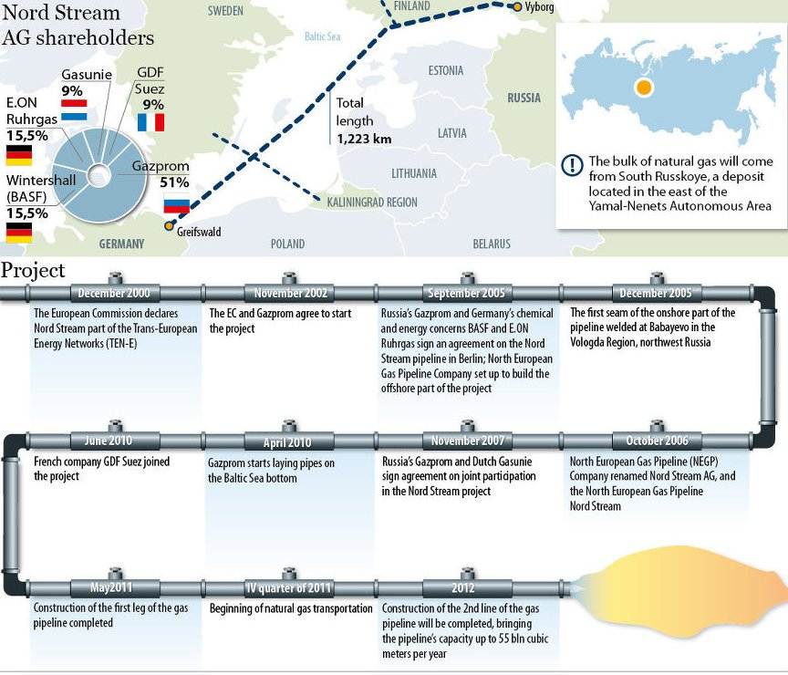

The Nord Stream construction [1]

VI. THE NORD STREAM SHAREHOLDERS

The main participants of the project are Russia, Germany, the Netherlands and France, as a result of which intergovernmental agreements, a consortium Nord Stream AG the owner and operator of the pipeline was organized. Stake in the project are distributed as follows: OAO “Gazprom” – 51%; Wintershall (from the BASF) – 15,5%; E.ON Ruhrgas (group E.ON) – 15,5%; NV Nederlandse Gasunie (Netherlands) – 9%, Group GDF SUEZ (France) – 9%. Supreme governing body of Nord Stream AG is the committee of shareholders, which is headed by former Chancellor Gerhard Schroeder.
All participants of the Nord Stream project are the largest and most reputable companies, which hold powerful energy resources and a developed network of transnational gas pipelines. As a result of the project the north-western Europe countries will receive 55 billion cubic meters of raw materials per year, which is about 25% of additional gas imports. Moreover, investments made in 11 European countries, helped to create new jobs.

- THE NORD STREAM INVESTORS

The first loan of € 3,9 billion for the construction of the first gas pipeline Nord Stream AG received 16 March 2010 from the 26 largest banks in the world including BNP Paribas SA, Commerzbank, Credit Suisse, Deutsche Bank, Hermes, ING Bank NV, RaiffeisenZentralbank, Royal Bank of Scotland, Sace, Societe Generale, Standart Bank Plc, The Bank of Tokyo-Mitsubishi UFJ Ltd, UniCredit, West LB.

VII. THE NORD STREAM CONTRACTORS

The main contractors for the project were selected by an international tender:
- technical design of the pipeline - Saipem Energy Services SpA (Italy);
- pipe-construction on the sea section of the route – Saipem Energy Services SpA (Italy) (pipe-laying vessels Castoro 6, Castoro 10, Solitaire;
- pipes for the first line supply – the German Europipe (75%), Russian “OMK” (25%)
- pipes for the second line supply – the German Europipe (65%), Russia's “OMK” (25%), Japanese Sumitomo (10%);
- construction of the Russian land section – “Stroygazkonsalting”;
- gas turbines for land-based section of the pipeline supply – “Perm Motor Plant”.

VIII. OBJECTIONS AGAINST THE NORD STREAM CONSTRUCTION

Objections against the Nord Stream construction were expressed by representatives of Poland and the Baltic countries, which were afraid off the negative impact of the pipeline on the Baltic Sea environment. The Polish representatives insisted that the construction of a transit line on the land through its territory would be cheaper and would not allow increasing the share of Russian gas in total gas import to Europe. The Polish government also planned to stop the project insisting on their rights to the waters to the south of Bornholm, however, later the northern bypass of the island was selected. In 2006, Polish Defense Minister Radek Sikorski called the North European Gas Pipeline “new Molotov-Ribbentrop Pact”, which aroused indignation of the Russian and German sides. Estonia, which was offered to have the part of the pipeline on its exclusive economic zone, in 2007 refused Nord Stream research vessel to get access to its water. However, in June 2008 during the summit of the Baltic Sea countries Lithuanian and Estonian representatives declared that they would not oppose the project and Latvian Prime Minister Ivars Godmanis even expressed his support: “The more pipes we have, the better it is!”.
Belarussia was also against the construction of the Nord Stream as it insisted on increasing the capacity of the Yamal-Europe and instead offered free gas transit through its territory in exchange. Contradictions against the pipeline in 2006 were expressed by representatives of the U.S. State Department, which feared that the project would increase Europe's dependence on Russian gas.

- ECOLOGIC PROBLEMS OF THE NORD STREAM

A lot of attention while designing and constructing of Nord Stream was paid to environmental safety issues. Over 100 million Euros were spent on the research of the ecosystem of the Baltic Sea.
The Baltic Sea is considered to be the dirtiest in the world because of active transportation, and raw sewage. Estonia, Finland and other Baltic countries as well as representatives of various environmental organizations, in particular, Greenpeace expressed their dissatisfaction with environmental consequences of Nord Stream. They claimed that the pipeline could affect buried chemical weapons in the Baltic Sea and lead to environmental catastrophe. However, the Nord Stream AG operating company managed to cooperate with them.
In response to environmental criticism Nord Stream AG conducted researches of environmental impact of the pipeline on the Baltic Sea several times. Chairman of the E.ON group Ruhrgas Bernhard Reutersberg assured stakeholders that the Nord Stream project enters “the new level of advanced technology and effective protection of the environment”. Moreover, the company-operator representatives reported that such important for the Baltic Sea ecosystem factors as spawning and migration of migratory birds were also taken into account in the construction of the pipeline. It was stated that the construction and operation of the pipeline would not violate the boundaries of the spawning grounds and the main commercial fish food supply, as well as trade routes and tourist routes.
The question that the pipeline could disturb the graves of both chemical and conventional weapons of Nazi Germany in the Baltic Sea, so that could happen ecological disaster was raised. In response, the consortium hired several companies, including experts of the Navy of Russia, in order to check the route of the future gas pipeline in the presence of chemical weapons and mines. It was found that there were some munitions on the seabed but the pipeline bypasses the dangerous accumulations. Clearing the seabed in Finnish waters (Blast-min) started in autumn 2009. Totally it was required to neutralize tens of minutes along the gas pipeline route.
These and many other issues were successfully resolved. In the future, monitoring of subsea pipeline route will be conducted on an ongoing basis. For this purpose, up to 2016, almost 40 million Euros will be spent.

X. BENEFITS FOR THE NORD STREAM INVESTORS

The main benefits for Nord Stream investors are presented below:
- The European gas consumption. Nowadays no one doubts that the European gas consumption in the near future will increase enormously mainly due to the refusal of some European countries (e.g. Germany) from the nuclear power industry. The domestic production of gas in Europe will decline as reserves of the fields in the North Sea are already severely depleted. According to the EU experts shortage of gas will be about 200 billion cubic meters by 2030. Nord Stream operating at full capacity will supply 55 billion cubic meters. "Some additional supplies will be demanded and thus the need for other infrastructure projects – the “South Stream”, “Nabucco will increase” – the representative of Nord Stream AG said;
- Unreliability of Middle Eastern partners. At the same time suppliers from the Middle East and North Africa are not only less reliable, but also can stop the export at any time due to political instability in the region. Export flows of gas to Europe must fall in the next few years. Moreover, no North African natural gas pipelines are able to pump these volumes of “blue fuel” as the Russian gas pipeline;
- The safety of Nord Stream. Unlike other international gas projects, Nord Stream has its source in a safe Yuzhno-Russkoye field in Western Siberia. And the territory on which it constructed is rather politically stable.

XI. RISKS OF THE NORD STREAM INVESTORS

The main risks of Nord Stream investors are presented below:
  - Prohibitively high price for Russian gas which is absolutely inevitable according to very high costs for the construction of Nord Stream. If the Kremlin agreed to build a second gas pipeline “Yamal”, coming from Russia through Belarus and Poland to Germany, the construction would cost about $ 2 billion. For comparison, the construction of Nord Stream at the bottom of the Baltic sea was supposed to cost € 5,4 billion, construction of the second line of Nord Stream will cost the same price. Thus, there is huge overpayment, which compensation must be incorporated in the price of gas. The Western and Eastern Europeans now have to cover the difference. However, for example, more modern technology allows island states such as Australia and Trinidad and Tobago, supplying 'blue fuel' tank vessels anywhere in the world without long-term contracts. In the future, it may be much more profitable than the old one "pipes technology”;
  - The risk of additional costs. The cost of the Nord Stream was significantly higher than originally planned. The project has very high safety (including environmental) characteristics, which makes it too expensive. The construction cost of Nord Stream has risen twice since 2009 year. If the current pace of construction and the rise in prices are taken into account, the final bill of $ 28 billion can be assumed (this is the opinion of the world's leading energy analysts and project insiders);
  - The risk of Russian deposits depletion. Some experts believe that Moscow considerably overstates its capabilities as an energy supplier. Gazprom tends to penetrate deeper into the Arctic, as well as buys and resells surplus gas from Turkmenistan or Azerbaijan;
  - Law risks. The EU directives may be spread on the Nord Stream pipeline. According to the new European law, companies that are engaged in the sale, distribution or extraction of gas, may not own the gas transportation infrastructure. Meanwhile the Russian “Gazprom” and Germany E.ON earn by selling gas and if follow strictly all the EU directives, the pipeline must pass under independent management;
  - Political risks. Gazprom has rather peculiar reputation in Europe. The largest monopoly is believe to be the secret weapon of the Kremlin and it is also accused of creating of so-called “gas wars”. Such glory (whether it is true or not) only harms the business;
  - Technological risks. Nord Stream is said to have leaks in many places. Nowadays the gas leak is small but in the long term it may result in significant problems for the Baltic Sea environment. Accordingly, penalties and taxes will be presented to the company. Moreover, repair of the under the sea level pipeline is much more difficult and more expensive than the land one.
And if an accident happens suddenly, it violated all gas supplies to Europe. Nord Stream has no underground storage facilities which in case of emergency can immediately cover the shortage. It is clear that anyone, even a short-term failure in the supply of energy is fraught with major losses for both operators and investors.

XII. CONCLUSION

To sum up, the Nord Stream Pipeline through the Baltic Sea is the most direct connection between the vast gas reserves in Russia and energy markets in the European Union. In fact, in 2006 the European Parliament and Council designated the Nord Stream Pipeline as being of "European interest". This status is given to projects that strengthen markets and reinforce security of supply. [2]

REFERENCES

- http://ria.ru/- Russian information source
- www.nord-stream.com-official website of the Nord stream Project
- http://en.wikipedia.org/- Wikipedia

