ANALYSIS OF THE CAUSES AND EFFECTS OF FIELDBUS NETWORK INDUCED DELAYS IN
CONTROL SYSTEMS

Joseph Mainoo

Ph.D. Candidate – Indiana State University
Electronics and Computer Technology,
Bowling Green State University, Bowling Green, OH 43403, USA

Indiana State University
Terre Haute, Indiana, USA

Abstract

Fieldbus networks such as Controller Area Network (CAN), Foundation Fieldbus and Profibus, are extensively used in modern control system implementations. It is important to study the impact of these networks on control system stability and performance. This paper uses a software simulation tool called CANoe for the development and performance analysis of CAN fieldbus network. Statistical analysis using SPSS software is performed on the network delays data for an automobile system simulation. The analysis of the collected data shows that various CAN parameters have an effect on network delays. The impact of these delays on closed loop control system performance measures such as stability; peak overshoot; and settling time are also investigated. The paper demonstrates these effects on a control system with a Proportional, Integral, and Derivative PID controller using simulation of a DC motor model with MATLAB/Simulink software.

- Introduction

Fieldbus networks, such as Controller Area Network (CAN), Profibus, Foundation Fieldbus, are all-digital, two-way, multi-drop communication systems that are used to connect field devices such as sensors, actuators, and controllers in control systems [1]. The increasing popularity of fieldbus networks in automobile systems, factory automation, and power grid can be attributed to a host of advantages. These include: greater system functionality, simplicity, accuracy, less cost of purchase and expansion, interoperability, and other savings [1]. CAN-based networks are more accepted in automotive applications [2]. The introduction of fieldbus systems, however, introduces time delays in communicating among devices such as sensors, actuators, and controllers. This paper analyzes these network induced delays as they have significant impact on the systems [3, 4].
Recently, there have been several theoretical results reported in the literature that address these time delays and other aspects of networked control systems. For instance, Wang et al. [3] provided a model for computing the maximum and expected delays for CAN. A pole-placement based control algorithm was utilized to analyze delay problems in ISA Fieldbus by Abdel-Ghaffar et al. [5]. The temporal characteristics of communication and computation tasks, and the configuration of the function blocks was analyzed to allow the control interval to be shortened in a Foundation Fieldbus based control systems by Pang et al. [6]. The delays associated with the use of Foundation Fieldbus (FF) H1 networks within control loops were investigated by Rankin et al. [7]. In these ISA-S50 Foundation Fieldbus based networks, Link Active Scheduler plays an important role in the timing issues [8]. Tipsuwan et al. [9] surveyed recent articles in the Networked Control Systems (NCS) area. Special issues on NCS were edited by Antsaklis et al. [4]. Some researchers analyzed the effect of the time delays on traditional controllers such as Proportional, and Integral (PI) controller [9], while others gave new control designs that take the delays into account [4]. Some of the analysis results gave bounds on the allowable delays to preserve stability of the networked control systems [4, 9]. Azimi-Sadjadi [10] studied the stability of networked control systems in the presence of packet losses. Liu and Goldsmith [11] studied the effects of wireless network medium access control protocols on the performance of the networked control systems. Network induced time delay was stochastically modeled by Morales-Menendez et al. [12] for CAN. A method to calculate CAN message response times was given by Tindell et al. [13]. A probabilistic approach to determine response time distribution for messages in CAN was given by Kumar et al [14]. Schedulability analysis for CAN was discussed by Davis et al. [15]. Li et al. [16] investigated the delays associated with the use of Profibus-PA networks within control loops.
The existing delay analyses used analytical and stochastic methods to establish relationships for delays. This paper uses statistical analysis methods to study the effect of various CAN parameters on network delays using simulated data with CANoe for an automobile system [17]. CANoe simulation software has been used by other researchers [18, 19]. This paper also examines the impact of these delays on the step response performance of control systems. Section II gives a general overview of fieldbus network induced delays. Different types of network delays and factors affecting these delays are explained. Section III gives results from the statistical analysis of CAN fieldbus network induced delays. Section IV outlines the effect of fieldbus network induced delays on control system performance such as stability and step-response for different PID controller gains. Section V offers concluding remarks.

- FIELDBUS network INDUCED delays

The use of fieldbus networks such as CAN result in several advantages. However, the introduction of these networks introduces time delays in communicating among devices. Zhang et al. [3] indicated that the existence of time delays degrades control performance in network control systems. Depending on the medium access control (MAC) protocol of the control network, these delay can be constant, time varying, or random. MAC protocols commonly fall into either random access or scheduling [3]. Carrier sense multiple access (CSMA) is used in random access networks. Scheduling networks use Token passing (TP) and time division multiple access (TDMA). The control networks such as DeviceNet based on CAN and Ethernet use CSMA protocols.
Figure 1 shows two nodes that are repeatedly transmitting messages with respect to a fixed time line for random access networks during different types of conditions [3]. A node on a CSMA network monitors the network before each transmission. As shown in Type 1 of Figure 1, a node begins transmission instantly when the network is idle; otherwise it waits until the network is not busy [3]. A collision occurs when two or more nodes try to transmit at the same time. The approach to resolve the collision depends on the protocol used. For instance, CAN utilizes CSMA with a bitwise arbitration (CSMA/BA) protocol. Since CAN messages are prioritized, the message with the highest priority is transmitted without interruption when a collision occurs, and transmission of the lower priority message is terminated and it’s retried when the network is idle as shown in Type 2 of Figure 1. Ethernet also utilizes a CSMA with collision detection (CSMA/CD) protocol. All the affected nodes will back off when collision occurs, wait a random time and retransmit as shown in Type 3 of Figure 1. CSMA networks are considered nondeterministic; but higher priority messages have a better chance of timely transmission when messages are prioritized as in CAN [3].

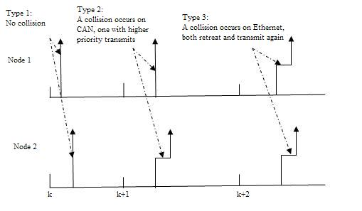
Fig. 1. Timing Diagram for Two Nodes on a Network

- Analysis of FIELDBUS network INDUCED delays

In this section the effect of different fieldbus network parameters on delays are analyzed. For this, CAN is used as an example. The effect of CAN parameters such as baud-rate (transmission speed), bus-load (% of bus activity) and message-length (0 to 8 bytes) on the delay time is studied. This is accomplished by gathering data from simulation of an automobile system using CANoe software. The panels of the automobile dashboard and various other consoles simulated are shown in Figure 2. The CAN messages considered for this analysis include ABSdata with identifier c9 and length 6 bytes, EngineData with identifier 64 and length 8 bytes, and GearBoxInfo with identifier 3fc and length 1 byte. The EngineData message consists of signals such as EngineSpeed with 16 bits length, EngineTemp with 7 bits length, IdleRunning with 1bit length, PetrolLevel with 8 bits length, EngForce with 16 bit length, and EngPower with 16 bit length. Similar signals are linked to the other messages c9 and 3fc.

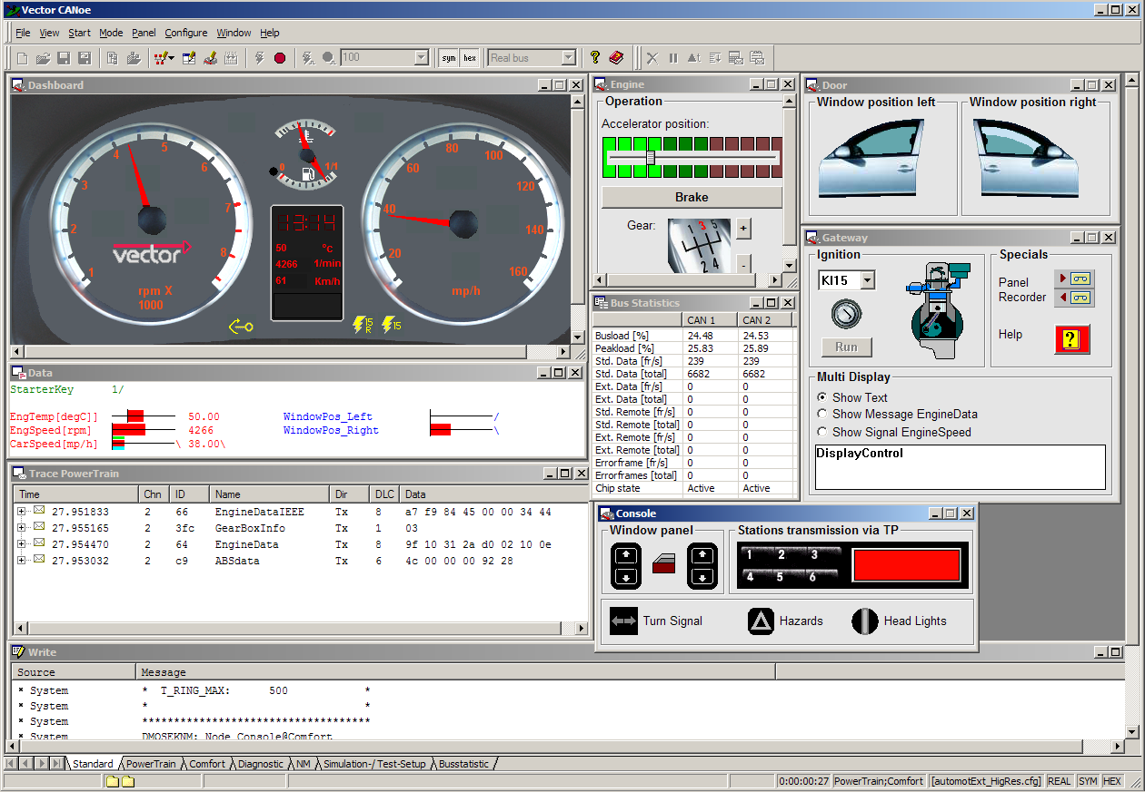

Fig. 2. Automobile Simulation Panel

This simulation allows various data sources in CANoe to place information or messages on the bus “cyclically” and by “event driven”. Each individual message has a unique identifier. Messages received by the controller gets the attribute R_{x} and a time stamp from the card’s clock when they are received. The driver returns the time of the transmit request assigned to the CAN microcontroller. The message to be transmitted is assigned an attribute T_{x}R_{q}. After the successful transmission, the message is returned with the actual time of transmission and the attribute T_{x}, so that the transmit messages can be displayed and logged in the Trace windows. The time between the message’s T_{x} attribute and T_{x}R_{q} attribute is the delay [17]. This is the time that the CAN controller needs to place a message completely on the CAN bus. The time delays are observed for all the messages at different baud rates, bus loads, and message lengths.
Figure 3 shows CAN bus activity for the automobile system executed at 100 kbps. For message identifier 64 (Hex) and c9 (Hex) the data is highlighted for one sample. The delay time (T_{x}-T_{x}R_{q}) for message with identifiers 64 and c9 are observed to be 0.001141 s (1.141 ms) and 0.00097 s (0.97 ms), respectively. Samples of delay times are collected for all the messages at different CAN parameters values such as baud rates, bus loads and message lengths during simulation runs. The data was analyzed using statistical methods [20] to study the effects of various CAN parameters on the delays.

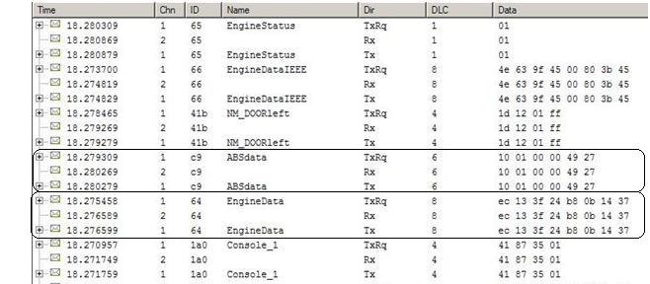

Fig. 3. Trace window showing bus activities executed at 100 kbps

Effect of Baud Rate on Network Delays
In this study 208 samples of delays for engine data signal with identifier 64 are collected at three different baud rates (50 kbps, 100 kbps, 200kbps) and analyzed using statistical package SPSS [20]. The histogram for 50 kbps is shown in Figure 4 with delays given in milliseconds (ms), and similar data is observed for the other two baud rates. The descriptive statistics obtained for this data is shown in Table 1. From this table it is clear that the mean values of the delays decrease with the increase in baud rate. The one-way Analysis of Variance (ANOVA) [20] gives the results shown in Table 2. The variability of mean delays between 50 kbps, 100 kbps, and 200 kbps baud rate groups, and variability of sample delays within each of these groups are shown in that table. Based on this information (F (2, 621) = 9027.746, p = 0.000), there is a statistically significant differences between the mean delay time for the different baud rates [20].
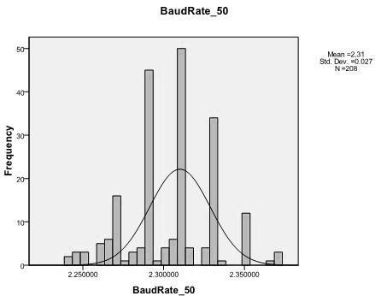

Fig. 4. Histogram for 50 kbps Baud Rate Data

Table 1.
Descriptive statistics of delay time for baud rates

 | N | Mean | Std. Deviation
BaudRate_50 | 208 | 2.30536 | 0.02689
BaudRate_100 | 208 | 1.16284 | 0.05714
BaudRate_200 | 208 | 0.76261 | 0.20078

Table 2.
Anova analysis of baudrate delays

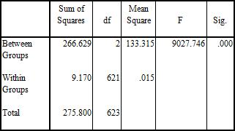

Effect of Message Length on Network Delays
For this study also 208 samples of delays for three different signals that have different message lengths are collected. The delays are in milliseconds (ms). The signals are engine data with identifier 64 (Hex) which has a message length of 8 bytes, ABS data with identifier c9 (Hex) which has a message length of 6 bytes, and gearbox info with identifier 3fc (Hex) which has a message length of 1 byte. Baud rate selected for this study is 200 kbps. The data is analyzed using statistical package SPSS [20]. The histogram for engine data with identifier 64 (Hex) signals that has the message length of 8 bytes is shown in Figure 5. Similar data is observed for the other two message length signals. The descriptive statistics obtained for this data is shown in Table 3. From this table it is clear that the mean values of the delays increase with the increase in message length. The one-way ANOVA analysis gives the results shown in Table 4. The variability of mean delays between 8 bytes, 6 bytes, and 1 byte data length groups, and variability of sample delays within each of these groups are shown in that table. Based on this information (F (2, 621) = 71.938, p = 0.000), there is a statistically significant difference between the mean delay time for the different message lengths considered [20].

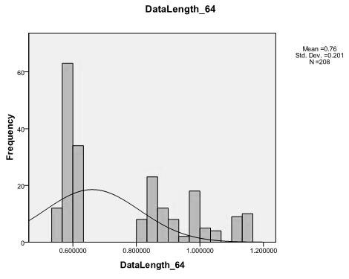

Fig. 5. Histogram for 8 Bytes Message Length

Table 3.
Descriptive statistics of delay for message length

 | N | Mean | Std. Deviation
DataLength 8_64 | 208 | 0.76261 | 0.20078
DataLength 6_C9 | 208 | 0.70553 | 0.22023
DataLength 1_3FC | 208 | 0.52079 | 0.22310

Table 4.
ANOVA analysis of message length delays

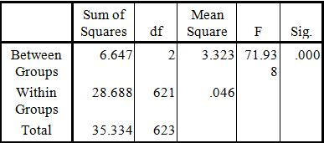

Effect of Bus Load on Network Delays
For this study 120 samples of delays for the signal 3fc (Hex) at two different bus loads are collected. The delays are in milliseconds (ms). The bus loads considered are 17% and 22%. The baud rate selected for this study is 100 kbps. The data is analyzed using statistical package SPSS [20]. The histogram for 17% bus load activity is shown in Figure 6. Similar data is observed for the other busload activity. The descriptive statistics obtained for this data is shown in Table 5. From this table it is clear that the mean values of the delays increased with an increase in busload. The one-way ANOVA analysis gives the results shown in Table 6. The variability of mean delays between 22% and 17% bus load groups, and variability of sample delays within each of these groups are shown in that table. Based on this information
(F (1, 238) = 18.483, p = 0.000), there is a statistically significant difference between the mean delay time for the different bus loads considered [20].
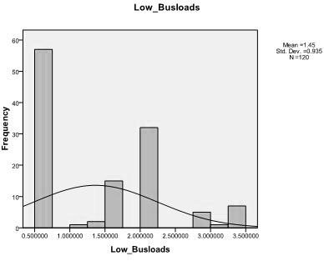

Fig. 6. Histogram for 17 % (Low Busload) Data

Table 5.
Descriptive statistics of delay for bus load
 | N | Mean | Std. Deviation
High Busload (22%) | 120 | 2.13697500 | 1.49216
Low Busload (17%) | 120 | 1.44580833 | 0.93544

Table 6.
ANOVA analysis of bus load delays

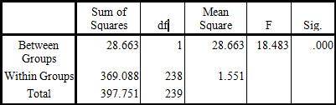

- EFFECT OF DELAYS ON CONTROL SYSTEMS

In this section, the effect of fieldbus network induced delays on control system performance such as stability and step-response for different PID controller gains are demonstrated using a DC motor model. The MATLAB/Simulink software tools are used to analyze the effects of these delays.
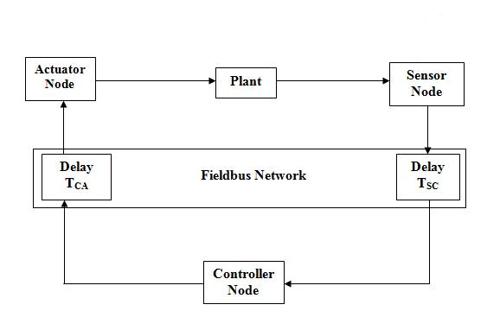
Fig. 7. Network Control System

In figure 7 τ_{CA} – Fieldbus Network Time Delay between Controller and Process Actuator; τ_{SC} – Fieldbus Network Time Delay between Process Sensor and Controller.
When fieldbus networks are used in the implementation of the closed loop system shown in Figure 7, as a result of the limited network bandwidth, two sources of delays may occur. These are sensor-to-controller delay (τ_{sc}) and controller to actuator delay (τ_{ca}). Any controller computational delay can be absorbed into either τ_{sc} or τ_{ca} without loss of generality. For fixed control law, time-invariant controllers, the sensor to controller delay and controller to actuator delay can be put together as τ = τ_{sc} + τ_{ca} for analysis purposes. The delays can affect the transient response behaviors in a control system. The general system performance as described by the criteria for step response may be degraded. This effect may include the increase of both overshoot and settling time of the system step response. The delays can also affect the stability of a system and cause the system to become unstable.
In this section the effects of network induced delays was studied using a DC Motor model Tipsuwan [3]. A Proportional, Integral and Derivative (PID) control scheme is used for this analysis to control the speed of the DC motor. The PI controller concepts studied by Tipsuwan et al., [3] were extended to include a Derivative mode. In order to compare the performance of these controllers under different network delays, the evaluation criteria used was: rise time, settling time, and percentage overshoot of the step response. The rise time is the time required for the DC motor speed to rise from 10% to 90% of its final steady-state value. The settling time is the time required for the DC motor speed to reach and stay within 5% range about the final value. The maximum overshoot is the maximum peak value of the DC motor speed measured from the unit step input. The PID gains used for K_{P}, K_{I} and K_{D} were 0.1701, 0.378 and 0.0075. For this controller, the graph of the step input, various outputs when network delays (τ_{sc} and τ_{ca}) have equal values of 0.00s, 0.03s, and 0.06s are shown in Figure 8.

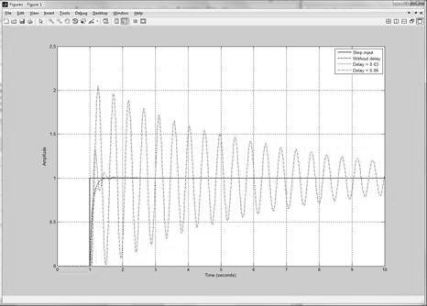

Fig. 8. Performance Measures for PID Controller at Different Delays

The PID controller response was observed to be better than the PI controller without delays with respect to percentage overshoot, though the settling time slightly increased [3]. It was also observed that the system performance gradually degraded as the network delays increased in values, and especially became unstable at values of delays beyond 0.06s. For instance, the system became unstable at delays of 0.07s, as shown in Figure 9. However, this PID controller improved the performance of the system as it accommodated more network delay values before it became unstable than that of the PI controller.

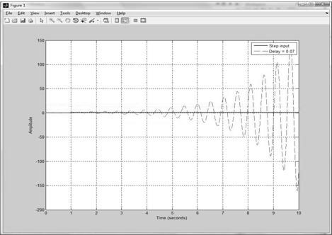

Fig. 9. PID Controller Performance when Delays (τ_{sc} and τ_{ca}) = 0.07s

Table 7 presents a summary of the step response information obtained after the simulations of the DC Motor with NCS using these PID controller gains. Controller Parameters are: K_{P} = 0.1701, K_{I} = 0.378,
K_{D} = 0.0075. For this PID controller the percentage overshoot increased with an increase in delay. The settling time increased with an increase in delays for higher delay values but the change was not significant at lower delay values. For example, the percentage overshoot and settling time for 0.02 s delay was 8.0% and 0.247 s respectively. The percentage overshoot was increased to 81.2% and the settling time also increased to 2.269 s when the delays became 0.05 s. From this study, it is observed that fieldbus network induced delays have an effect on control systems stability and performance as described by the system step response.

Table 7.
PID controller parameters and performance measures

 | Performance Measures
Delay (s) | Overshoot,  % | Peak Time,  s | Rise Time,  s | Settling Time,  s
0 | 0.40 | 0.615 | 0.186 | 0.267
0.01 | 0.50 | 0.605 | 0.146 | 0.229
0.02 | 8.00 | 0.137 | 0.060 | 0.247
0.03 | 32.80 | 0.162 | 0.056 | 0.470
0.04 | 57.00 | 0.192 | 0.056 | 0.910
0.05 | 81.20 | 0.222 | 0.055 | 2.269
0.06 | 105.30 | 0.254 | 0.056 | 14.92

- Conclusion

The purpose of this paper was to present an analysis of causes and effects of network induced delays in fieldbus networks. The CAN fieldbus network was used for part of these studies. An automobile system was simulated using CANoe software. The data obtained from the automobile system simulation for network delays was analyzed using statistical methods with SPSS program. Based on this data it was observed that the mean delay decreases with the increase in baud rate. The mean delay increases with the increase in message length of the transmitted signal. It was further observed that increase in busload increases the mean value of the network delay. One-way ANOVA analysis on the data collected confirmed that differences exist between these mean values of delays for different parameters. From the MATLAB/Simulink simulation of a DC motor in this study, it was observed that fieldbus network induced delays have an effect on control systems stability and performance as described by the system step response. The statistical information obtained through these simulations is useful to evaluate the performance of the hardware system. The results of this study are also useful to design PID controller gains, and the verification of how sensitive the control loops are under various time delays.

ACKNOWLEDGMENT

The author thanks Dr. Sri Kolla of Electronics and Computer Technology, BGSU for his help and support to this work. The author would also thank Mr. Bruce Emaus of Vector CANtech, Novi, MI, USA for providing CANoe software.

REFERENCES

- J. Berge, Fieldbuses for Process Control: Engineering, Operation, and Maintenance, Research Triangle Park, NC: ISA Press, 2002.
- U. Keskin, In-vehicle Communication Networks: A Literature Survey. Eindhoven: Technische Universiteit Eindhoven, VII, 2009. 1-53, Retrieved from http://alexandria.tue.nl/repository/books/652514.pdf.
- W. Zhang, M. S, Branicky, and S. M. Phillips, “Stability of Networked Control Systems,” IEEE Control Systems Magazine, vol. 21, 2001, pp. 84-99.
- P. Antsaklis and J. Baillieul (eds.), “Special Issue on Technology of Networked Control Systems,” Proceedings of IEEE, vol. 95, 2007, pp. 5-8.
- Abdel-Ghaffar, H., Hammad, S. and Zaki, A. (2008). H1 Fieldbus Network Delay; A Digital Pole Placement Control Design. Proceedings of the 17th World Congress the International Federation of Automatic Control, 9433-9436, Seoul, Korea.
- Pang, Y., Yang, S.-H. and Nishitani, H. (2006). Analysis of Control Interval for Foundation Fieldbus-Based Control Systems. ISA Transactions, 45 (3), 447 – 458.
- Rankin, Q. L., and Jiang, D. J. J. (2009). Evaluation of Delays Induced by Foundation Fieldbus H1 Networks. IEEE Transactions on Instrumentation and Measurement. 58(10), 3684-3692.
- ANSI/ISA-S50.02. (1997). Part 1: “Fieldbus Standard for Use in Industrial Control Systems – Introductory Guide”.
- Tipsuwan, Y. & Chow, M. Y. (2003). Control Methodologies in Networked Control Systems. Control Engineering Practice, 11, 1099-1111.
- Azimi-Sadjadi, B. (2003). Stability of Networked Control Systems in the Presence of Pocket Losses. Proceedings of the 2003 IEEE Conference on Decision and Control.
- Liu, X. & Goldsmith, A. (2004). Wireless Medium Access Control in Networked Control Systems. Proceedings of the American Control Conference.
- R. Morales-Menendez, L. Garza-Castanon, R. Vargas-Rodriguez and R. Ramirez-Mendoza, “Time Delay in Controller Area Network (CAN)-Based Networked Control Systems,” NAMRI/SME Trans., vol. 37, 2009, pp. 221-228.
- K. Tindell, A. Burns, and A. J. Wellings, “Calculating Controller Area Network (CAN) Message Response Times,” Control Engineering Practice, vol. 3, no. 8, pp. 1163, 1995.
- M. Kumar, A. K. Verma, and A. Srividya, “ Response-Time Modelling of Controller Area Network (CAN)” in Distributed Computing and Networking, V. G. Wattenhofer, and K. Kothapalli, Eds. Berlin: Springer-Verlag, 2009, pp. 163-174.
- R. I. Davis, A. Burns, R. J. Bril and J. J. Lukkien, “Controller Area Network (CAN) Schedulability Analysis: Refuted, Revisited and Revised,” Real-Time Systems, vol. 35, issue. 3, 2007, pp. 239-257.
- Q. Li, J. Jiang and D. J. Rankin, “Evaluation of Delays Induced by Profibus PA Networks,” IEEE Trans. Instrum. Meas., vol. 60, no. 8, 2011, pp. 2910-2917.
- Vector[CANoe], The Professional Development and Test Tool for CAN, LIN, MOST, FlexRay, Ethernet and J1708, 2011. Retrieved from http://www.vector.com/vi_canoe_en.html.
- C.-J. Zhou, H Chen, Y.-Q. Qin, Y.-F. Shi and G.-C. Yu, “Self-organization of Reconfigurable Protocol Stack for Networked Control Systems,” International Journal of Automation and Computing, vol. 8, issue. 2, 2011, pp. 221-235.
- F. Zhou, S. Li, and X. Hou, “Development Method of Simulation and Test Stystem for Vehicle Body CAN Bus Based on CANoe,” 7th World Congress on Intelligent Control and Automation, WCICA 2008, pp. 7515 – 7519.
- M. J. Norusis, SPSS 17.0 Statistical Procedures Companion, New Jersey: Prentice Hall, 2009.

