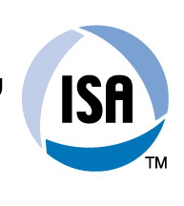

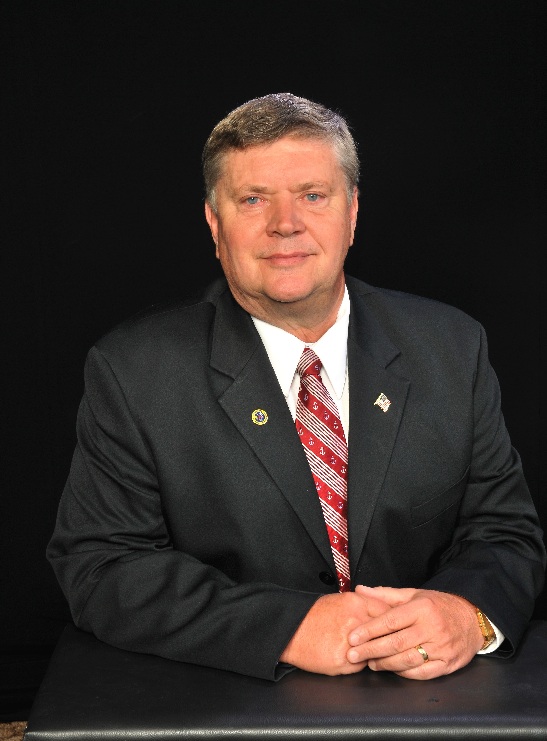

On behalf of ISA, I extend congratulations to the ISA Russia Section, ISA District 12, and the St. Petersburg State University of Aerospace Instrumentation (SUAI) on successfully completing the eighth ISA European Student Paper Competition.

We are excited about these talented individuals who will be instrumental in shaping the processes that will enhance our lifestyle in the 21st century. No matter which career path they choose, we hope ISA will continue to play an important role in their continuing education and professional development.

The papers published in this volume, selected by the advisory committee, represent the best contributions from among an excellent group of papers. The students who committed their time to prepare a paper should be very proud to be selected for this publication.

Sincerely,
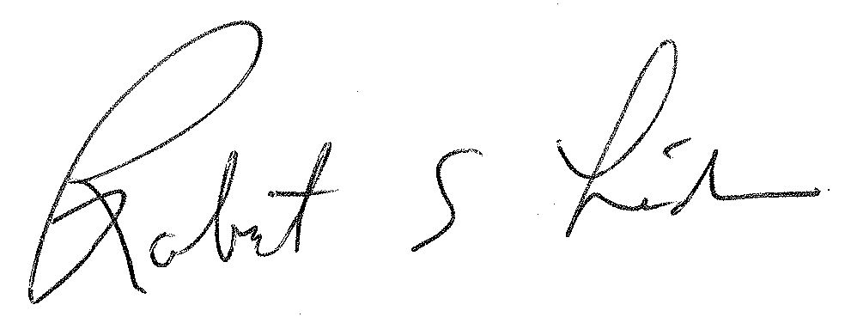

Robert E. Lindeman
2012 ISA President

